实验4第一题：

1、foreach

from pyspark import SparkConf, SparkContext

if __name__ == '__main__':

conf = SparkConf().setMaster("local[*]").setAppName("My App")

sc = SparkContext(conf = conf)

lines = sc.textFile("file:///usr/local/spark/mycode/rdd/word.txt")

lines.foreach(print)

sc.stop()

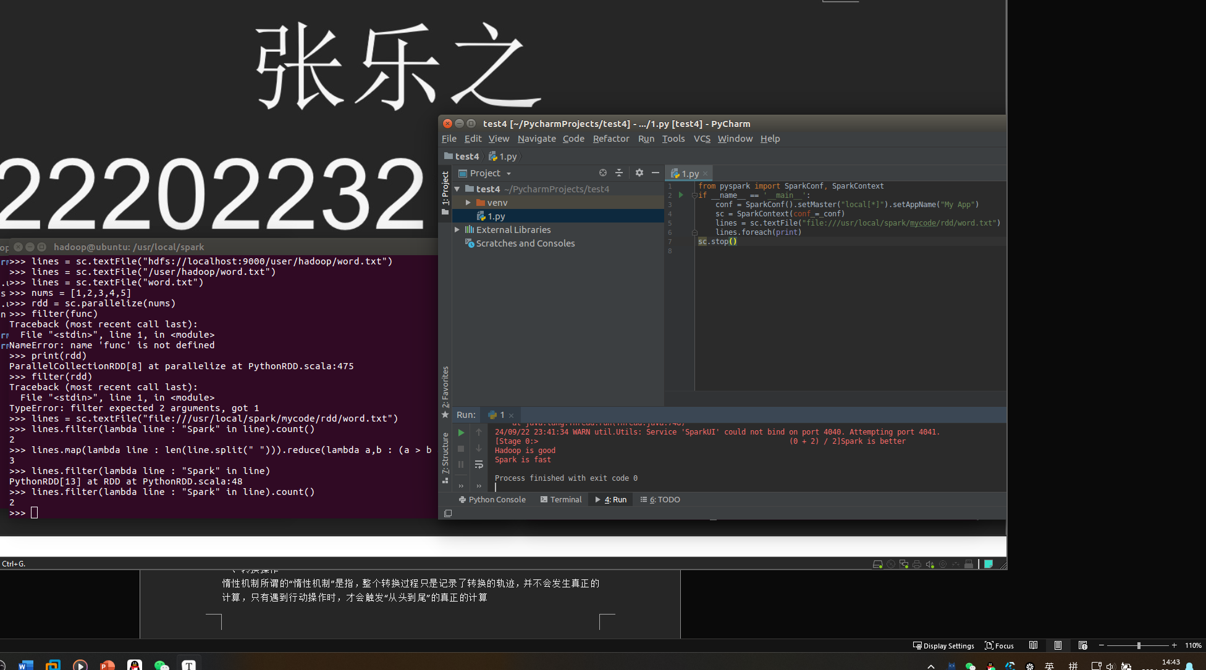

>>> array = [1,2,3,4,5]

>>> rdd = sc.parallelize(array)

>>> rdd.foreach(print)

1

2

3

4

5

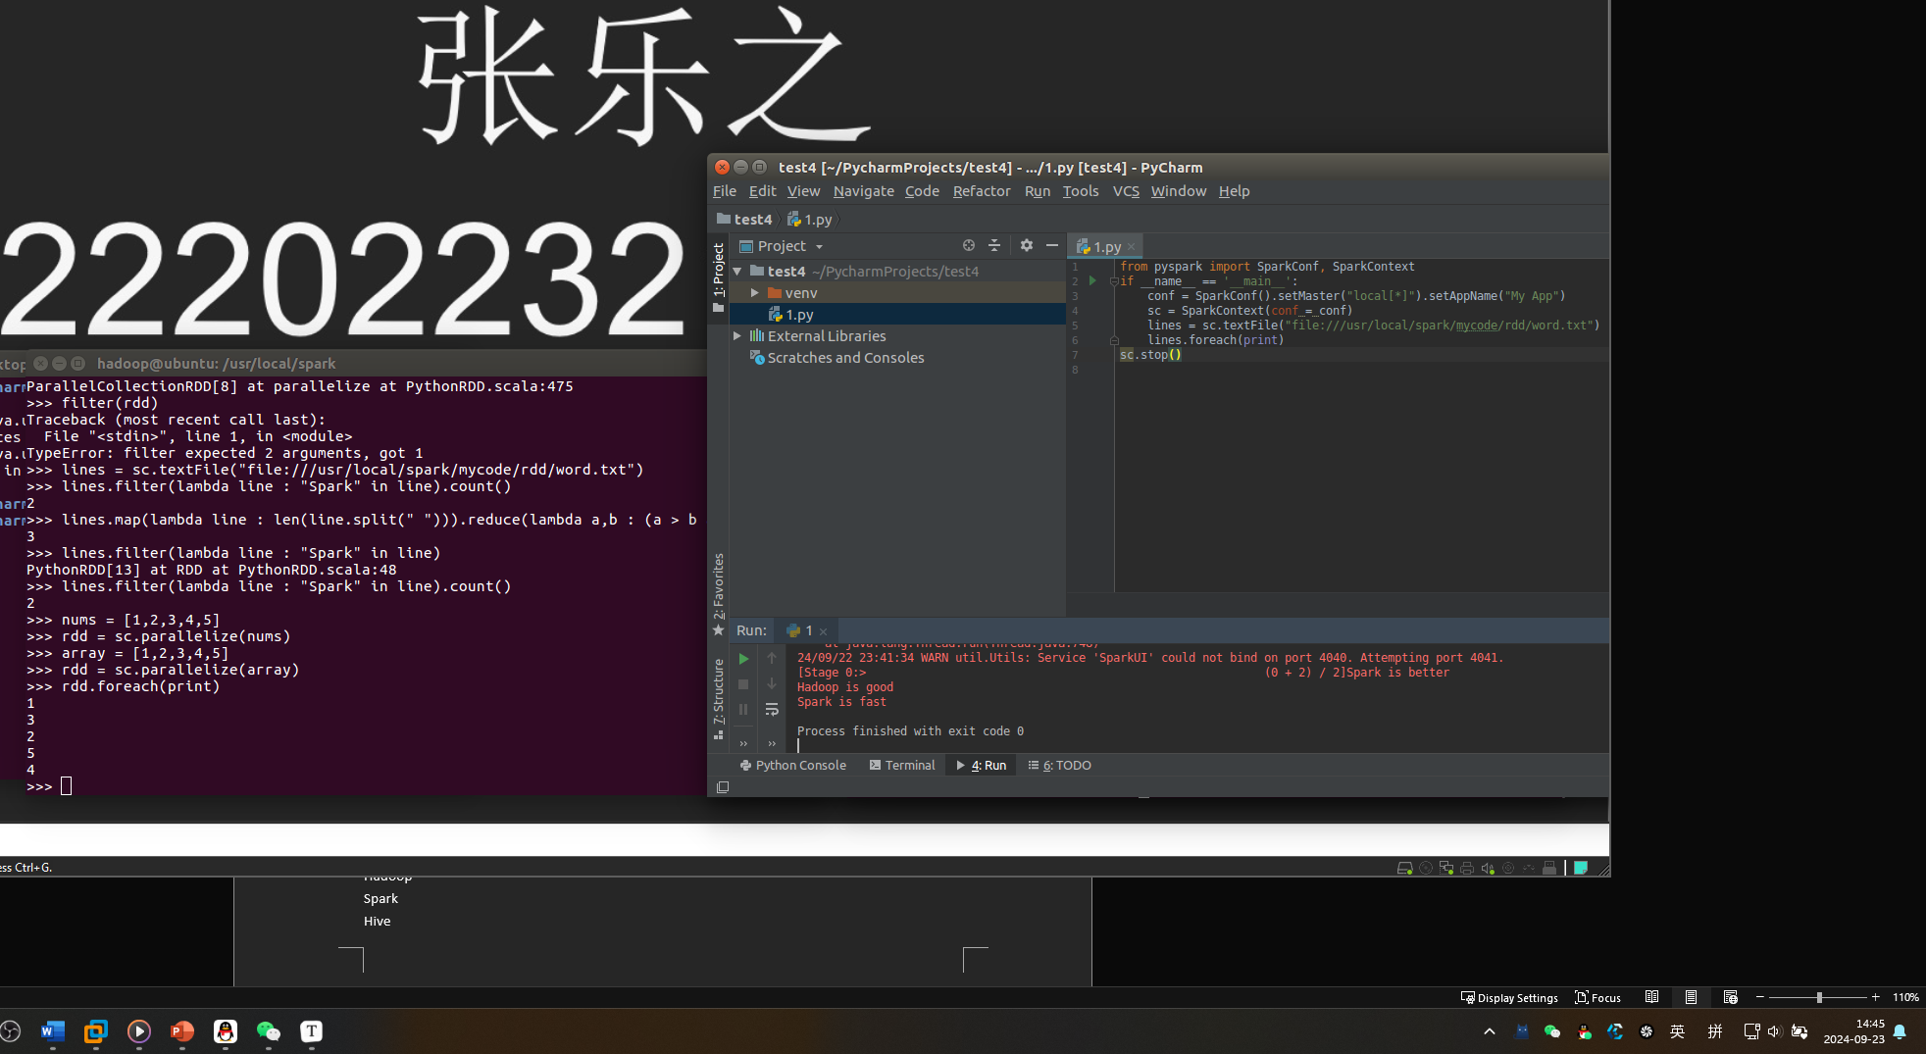

键值（K，V）：

>>> list = [("Hadoop",1),("Spark",1),("Hive",1),("Spark",1)]

>>> pairRDD = sc.parallelize(list)

>>> pairRDD.keys().foreach(print)

Hadoop

Spark

Hive

Spark

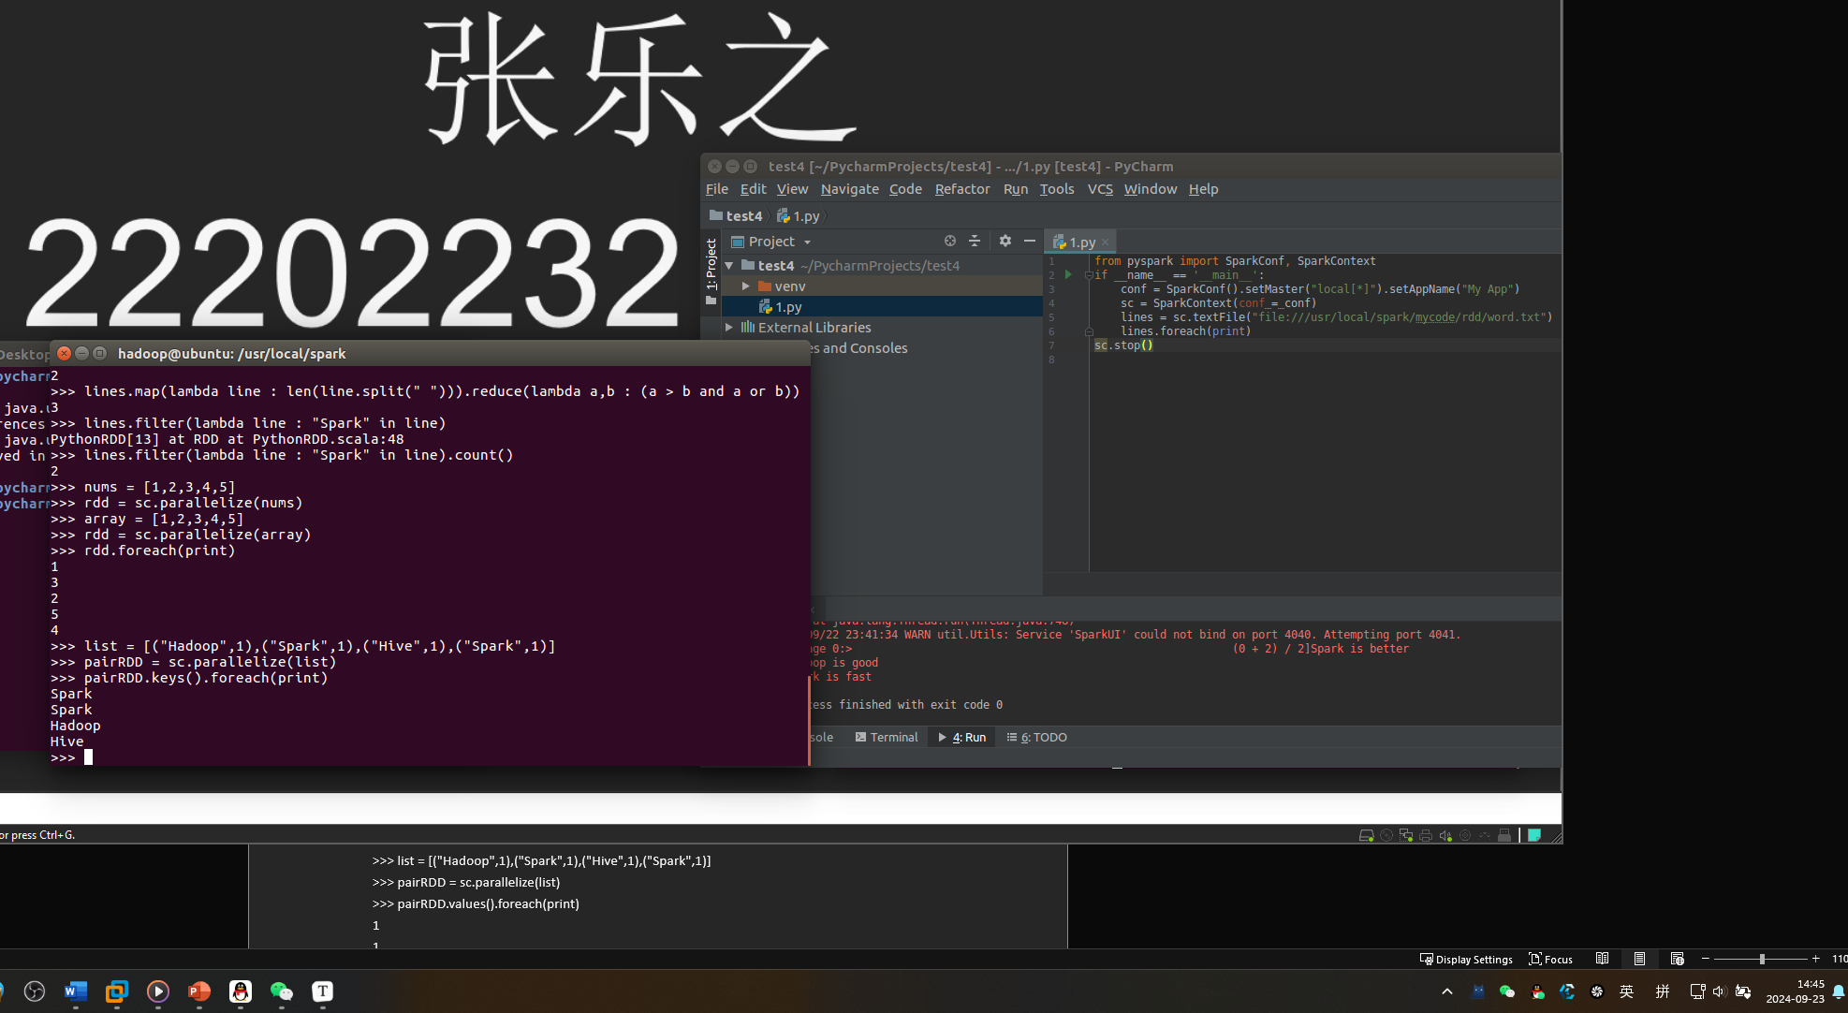

>>> list = [("Hadoop",1),("Spark",1),("Hive",1),("Spark",1)]

>>> pairRDD = sc.parallelize(list)

>>> pairRDD.values().foreach(print)

1

1

1

1

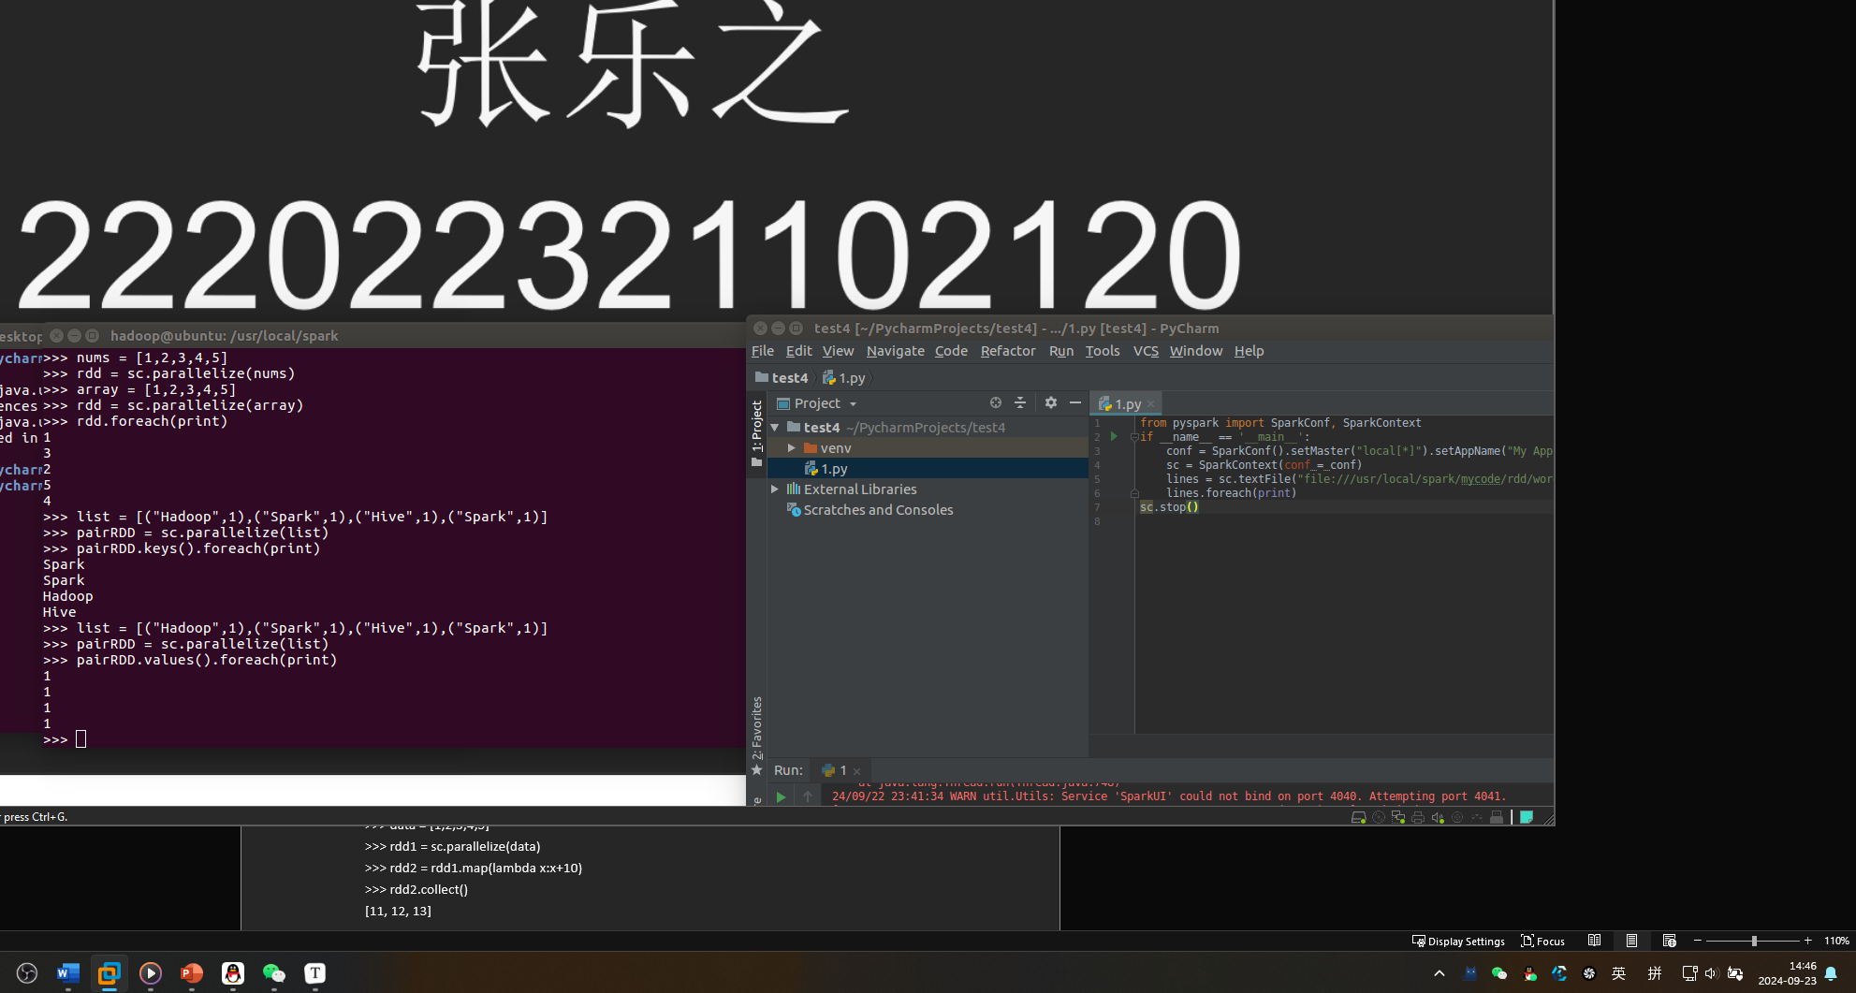

1. 转换操作

惰性机制所谓的“惰性机制”是指，整个转换过程只是记录了转换的轨迹，并不会发生真正的计算，只有遇到行动操作时，才会触发“从头到尾”的真正的计算

2、filter

>>> lines = sc.textFile("file:///usr/local/spark/mycode/rdd/word.txt")

>>> linesWithSpark = lines.filter(lambda line: "Spark" in line)

>>> linesWithSpark.foreach(print)

Spark is better

Spark is fast

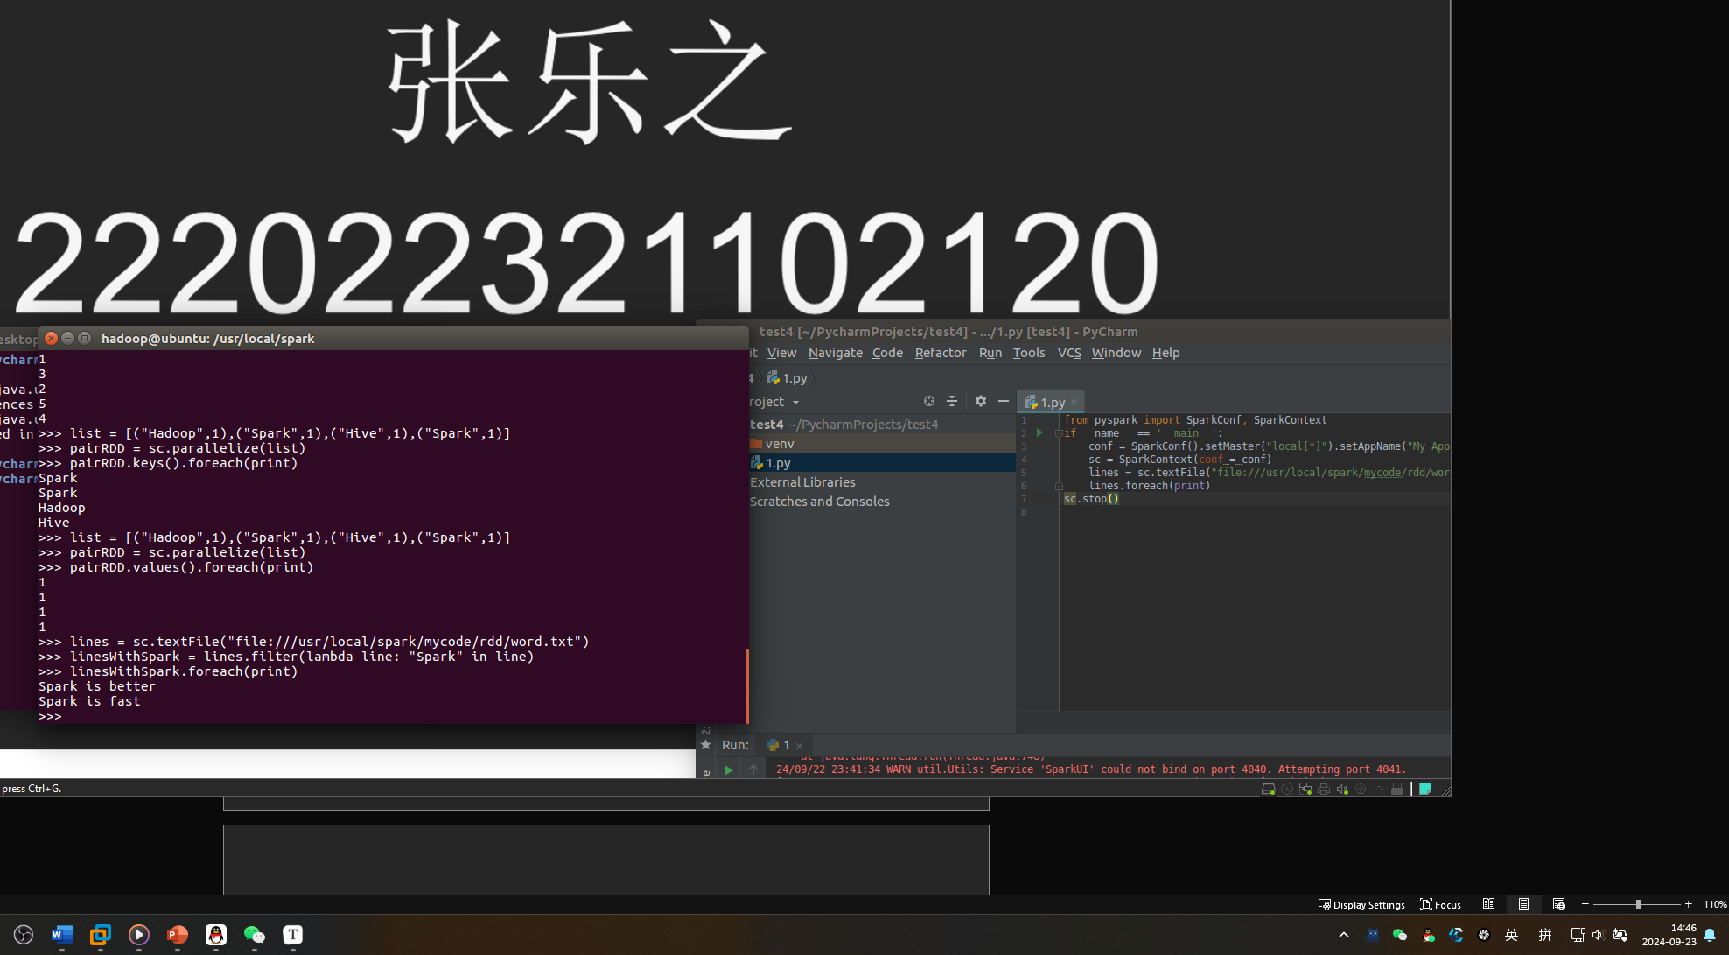

3、map

>>> data = [1,2,3,4,5]

>>> rdd1 = sc.parallelize(data)

>>> rdd2 = rdd1.map(lambda x:x+10)

>>> rdd2.collect()

[11, 12, 13]

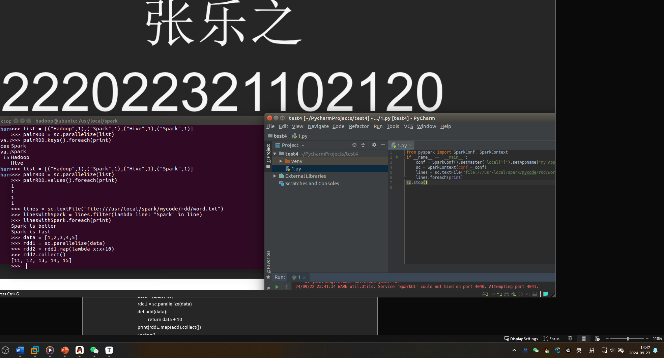

>>> lines = sc.textFile("file:///usr/local/spark/mycode/rdd/word.txt")

>>> words = lines.map(lambda line:line.split(" "))

>>> words.foreach(print)

['Hadoop', 'is', 'good']

['Spark', 'is', 'fast']

['Spark', 'is', 'better']

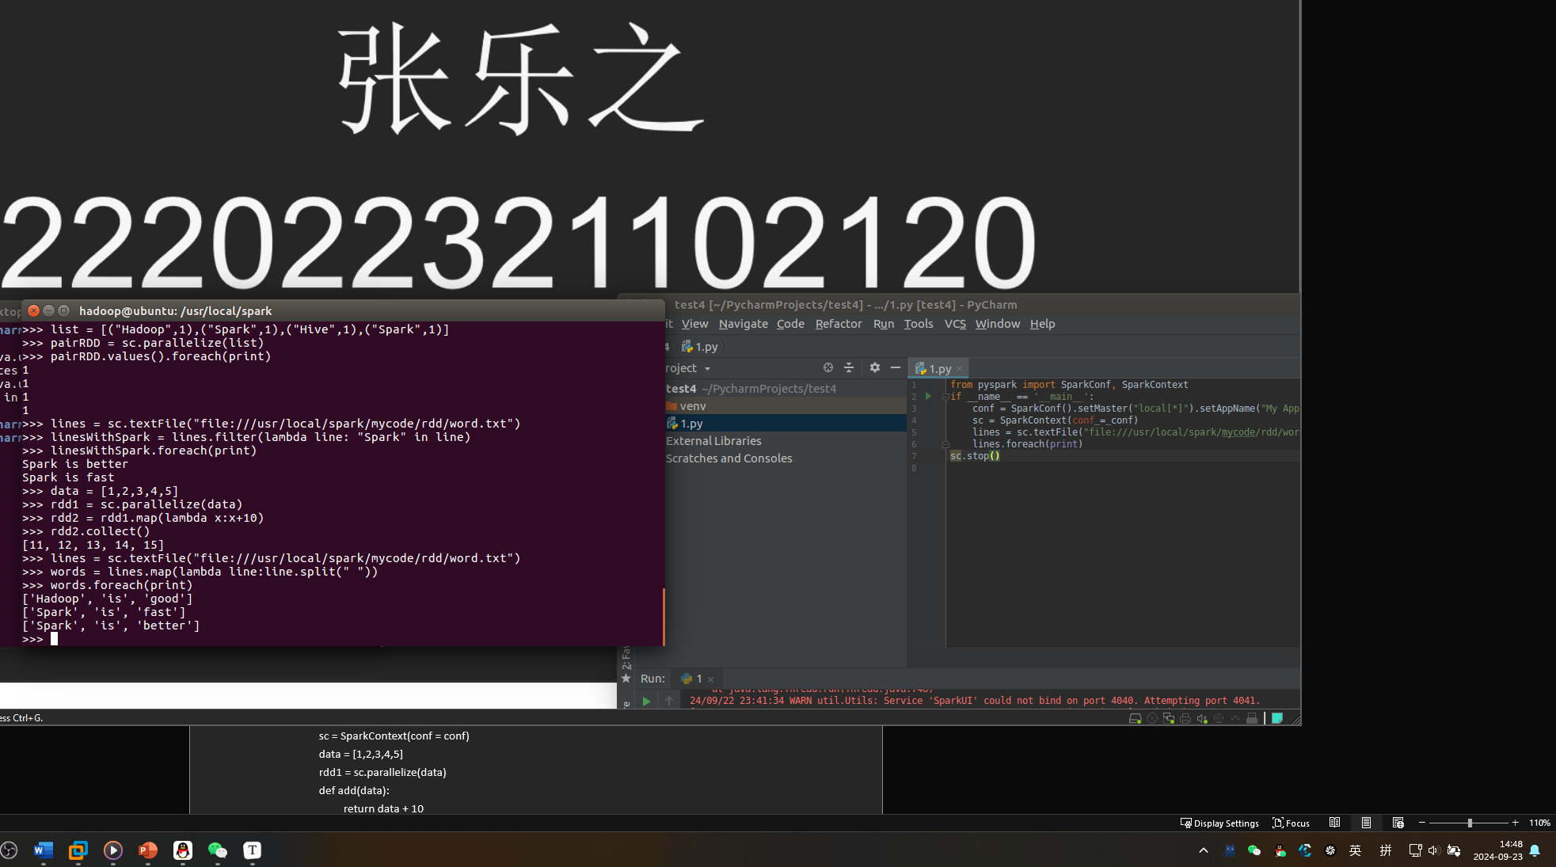

# coding:utf8

from pyspark import SparkConf, SparkContext

if __name__ == '__main__':

conf = SparkConf().setMaster("local[*]").setAppName("My App")

sc = SparkContext(conf = conf)

data = [1,2,3,4,5]

rdd1 = sc.parallelize(data)

def add(data):

return data + 10

print(rdd1.map(add).collect())

sc.stop()

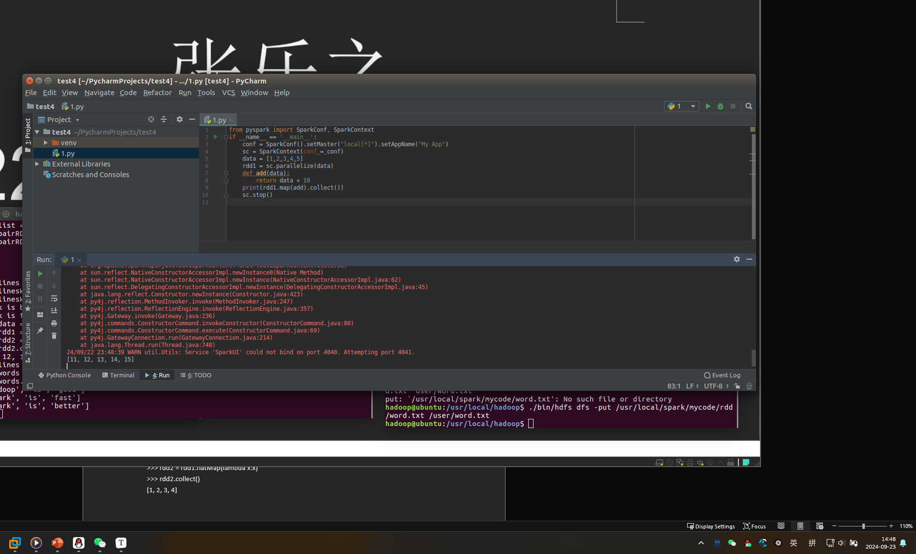

4、flatMap

>>> lines = sc.textFile("file:///usr/local/spark/mycode/rdd/word.txt")

>>> words = lines.flatMap(lambda line:line.split(" "))

>>> words.collect()

['Hadoop', 'is', 'good', 'Spark', 'is', 'fast', 'Spark', 'is', 'better']

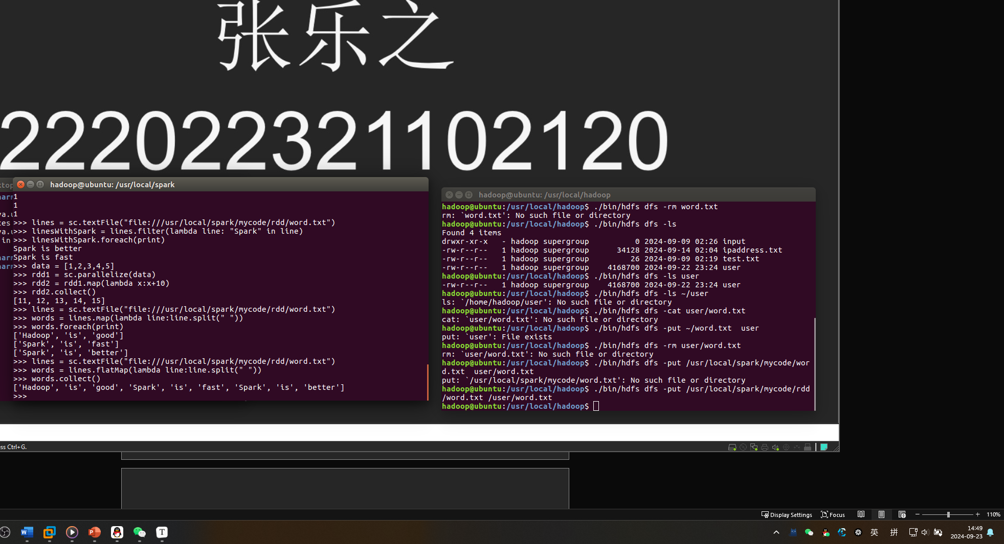

>>> rdd1 = sc.parallelize([[1,2], [3,4]])

>>> rdd2 = rdd1.flatMap(lambda x:x)

>>> rdd2.collect()

[1, 2, 3, 4]

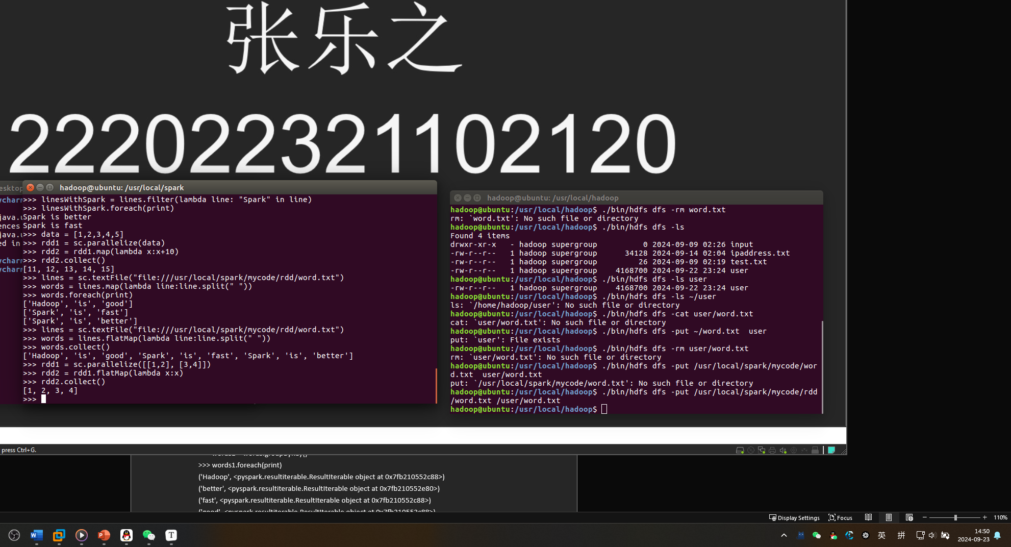

5、groupByKey

>>> words = sc.parallelize([("Hadoop",1),("is",1),("good",1), ("Spark",1),("is",1),("fast",1),("Spark",1),("is",1),("better",1)])

>>> words1 = words.groupByKey()

>>> words1.foreach(print)

('Hadoop', <pyspark.resultiterable.ResultIterable object at 0x7fb210552c88>)

('better', <pyspark.resultiterable.ResultIterable object at 0x7fb210552e80>)

('fast', <pyspark.resultiterable.ResultIterable object at 0x7fb210552c88>)

('good', <pyspark.resultiterable.ResultIterable object at 0x7fb210552c88>)

('Spark', <pyspark.resultiterable.ResultIterable object at 0x7fb210552f98>)

('is', <pyspark.resultiterable.ResultIterable object at 0x7fb210552e10>)

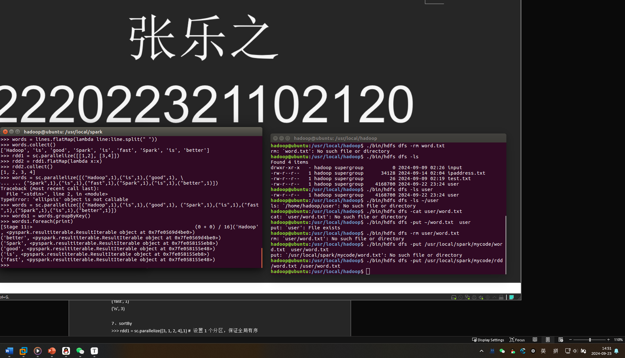

6、reduceByKey

>>> words = sc.parallelize([("Hadoop",1),("is",1),("good",1),("Spark",1), ("is",1),("fast",1),("Spark",1),("is",1),("better",1)])

>>> words1 = words.reduceByKey(lambda a,b:a+b)

>>> words1.foreach(print)

('good', 1)

('Hadoop', 1)

('better', 1)

('Spark', 2)

('fast', 1)

('is', 3)

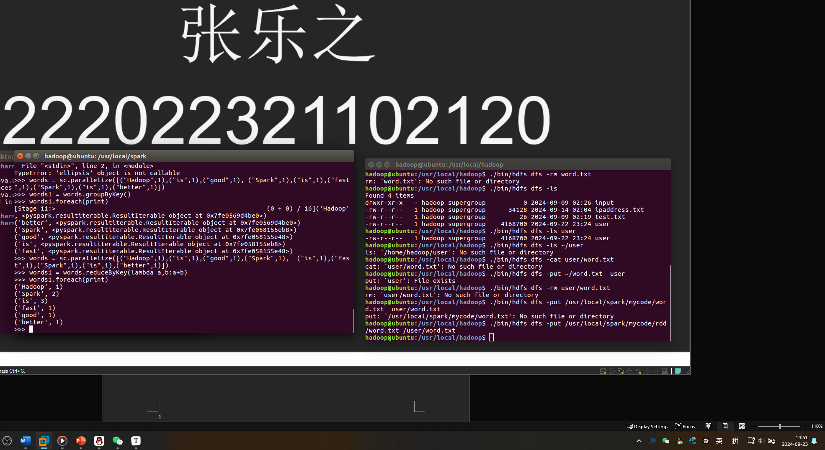

7、sortBy

>>> rdd1 = sc.parallelize([3, 1, 2, 4],1) # 设置1个分区，保证全局有序

>>> rdd2 = rdd1.sortBy(lambda x:x)

>>> rdd2.foreach(print)

1

2

3

4

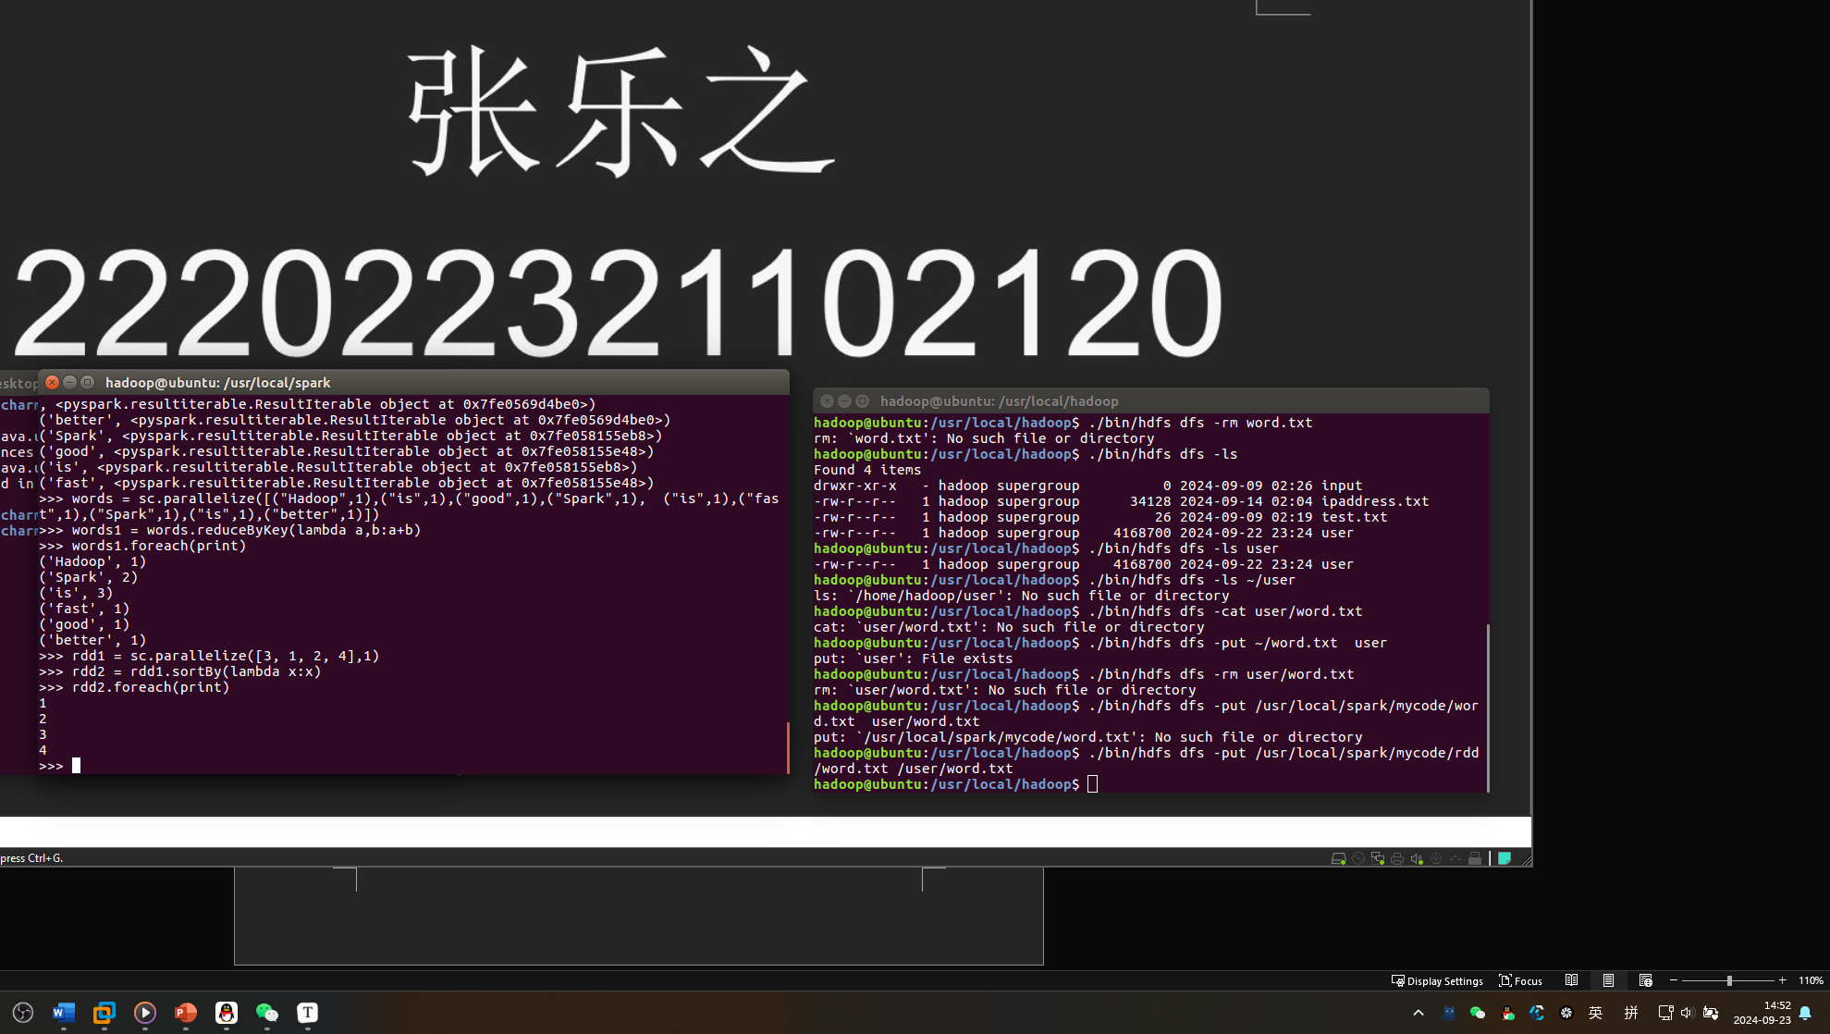

>>> rdd2 = rdd1.sortBy(lambda x:x,False) #使用参数False，实现降序排序

>>> rdd2.foreach(print)

4

3

2

1 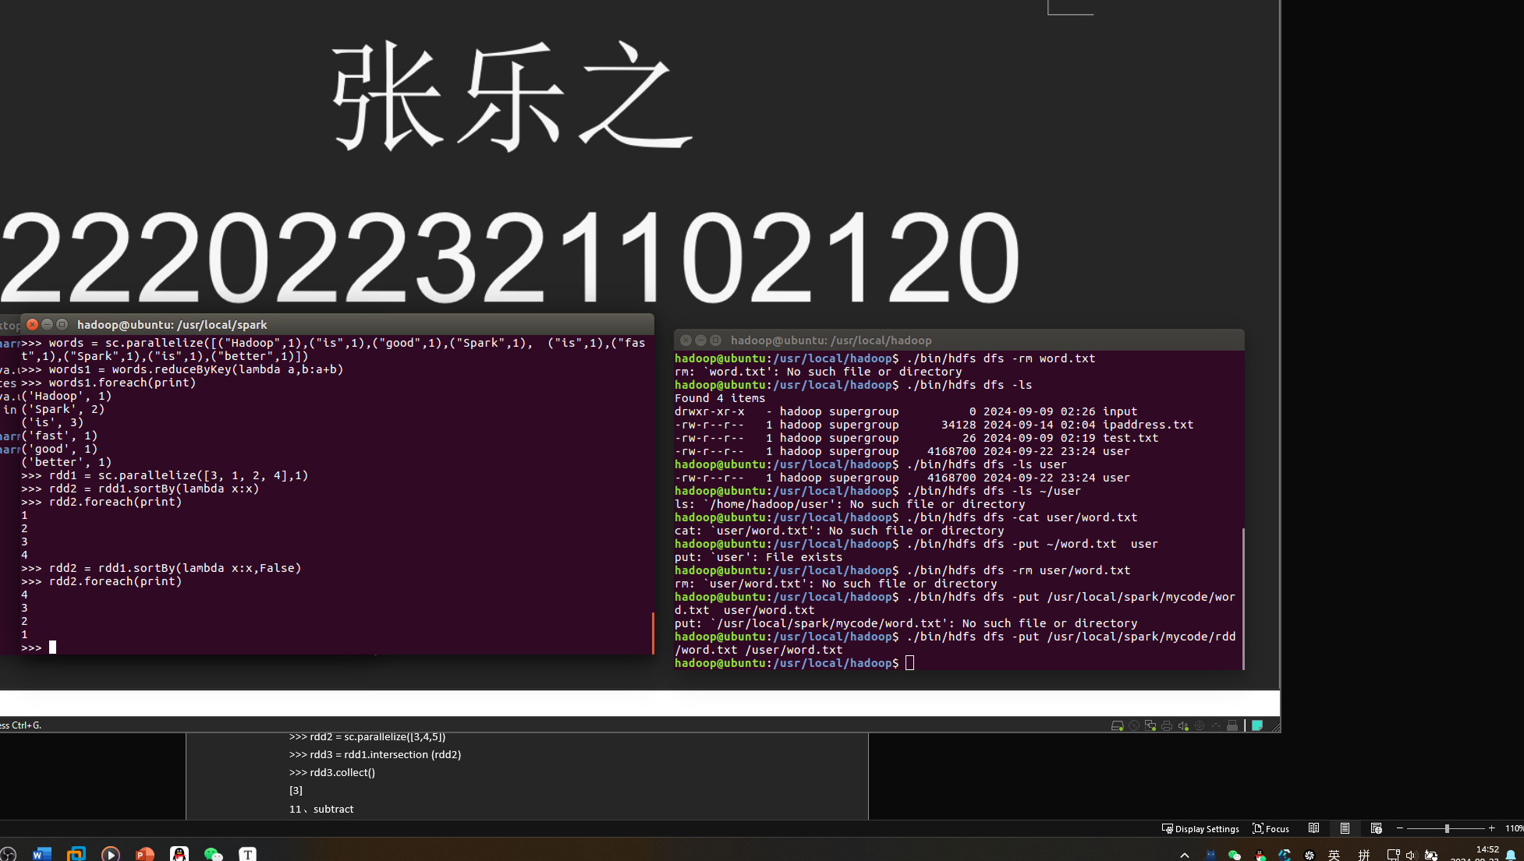

8、distinc

>>> rdd1 = sc.parallelize(["Flink","Spark","Spark"])

>>> rdd2 = rdd1.distinct()

>>> rdd2.foreach(print)

Flink

Spark

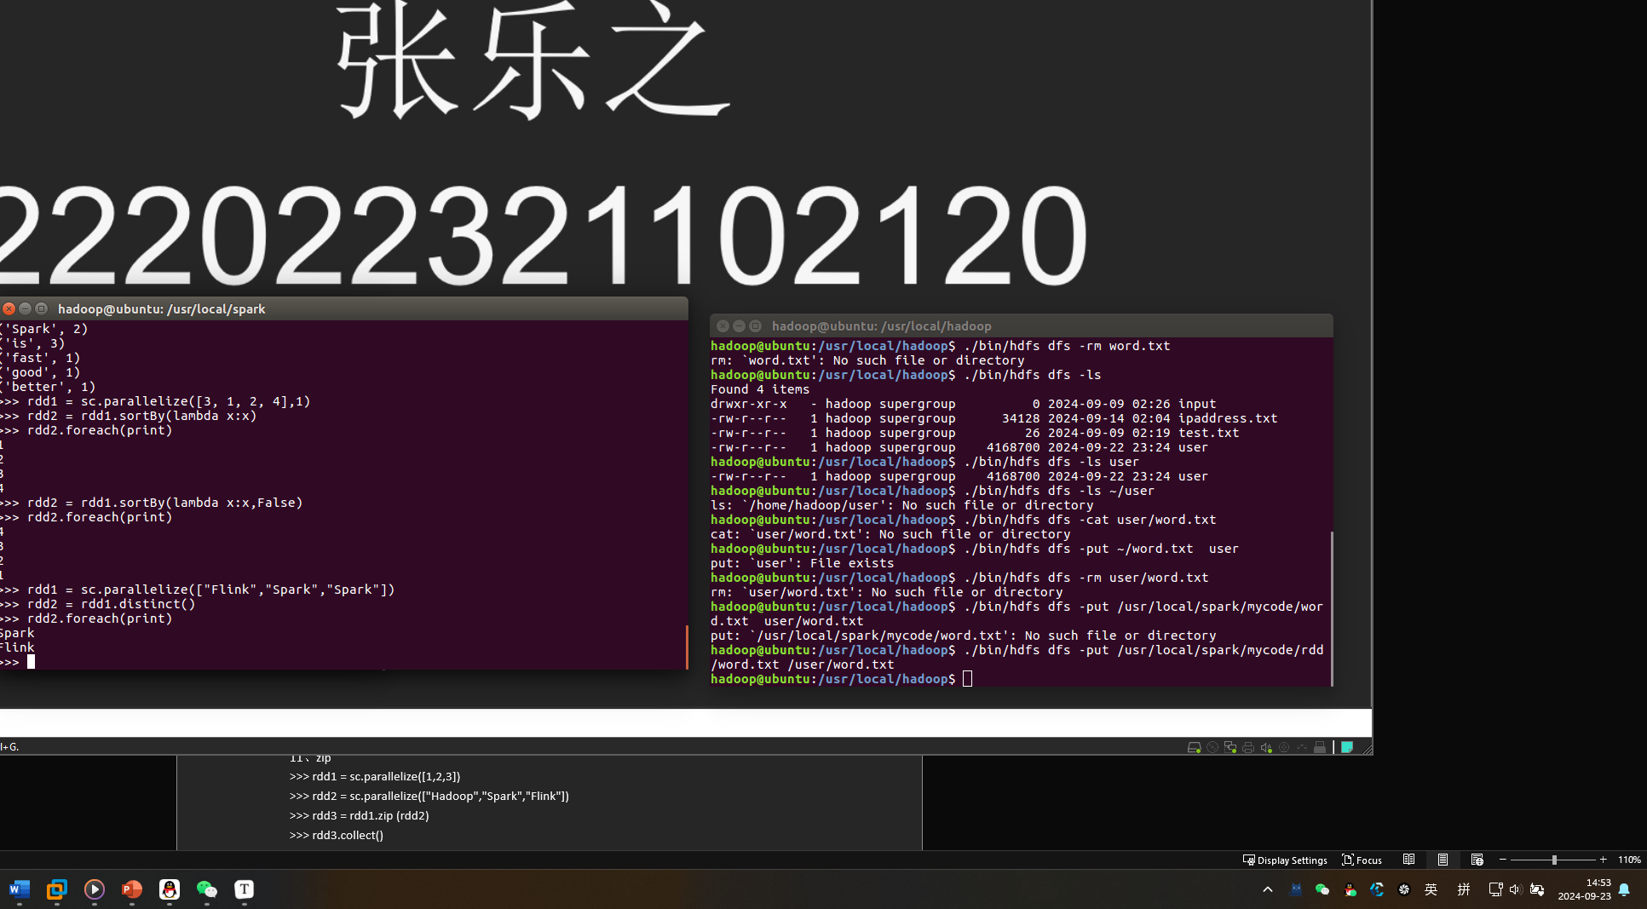

9、union

>>> rdd1 = sc.parallelize([1,2,3])

>>> rdd2 = sc.parallelize([3,4,5])

>>> rdd3 = rdd1.union(rdd2)

>>> rdd3.collect()

[1, 2, 3, 3, 4, 5]

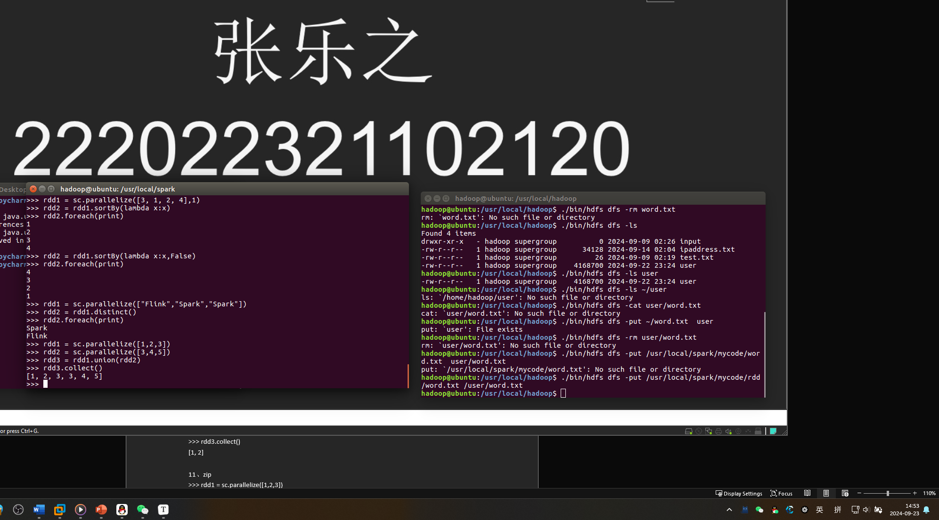

10、intersection

>>> rdd1 = sc.parallelize([1,2,3])

>>> rdd2 = sc.parallelize([3,4,5])

>>> rdd3 = rdd1.intersection (rdd2)

>>> rdd3.collect()

[3]

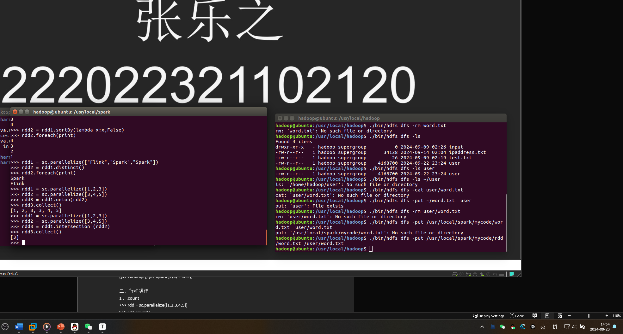

11、subtract

>>> rdd1 = sc.parallelize([1,2,3])

>>> rdd2 = sc.parallelize([3,4,5])

>>> rdd3 = rdd1.subtract (rdd2)

>>> rdd3.collect()

[1, 2]

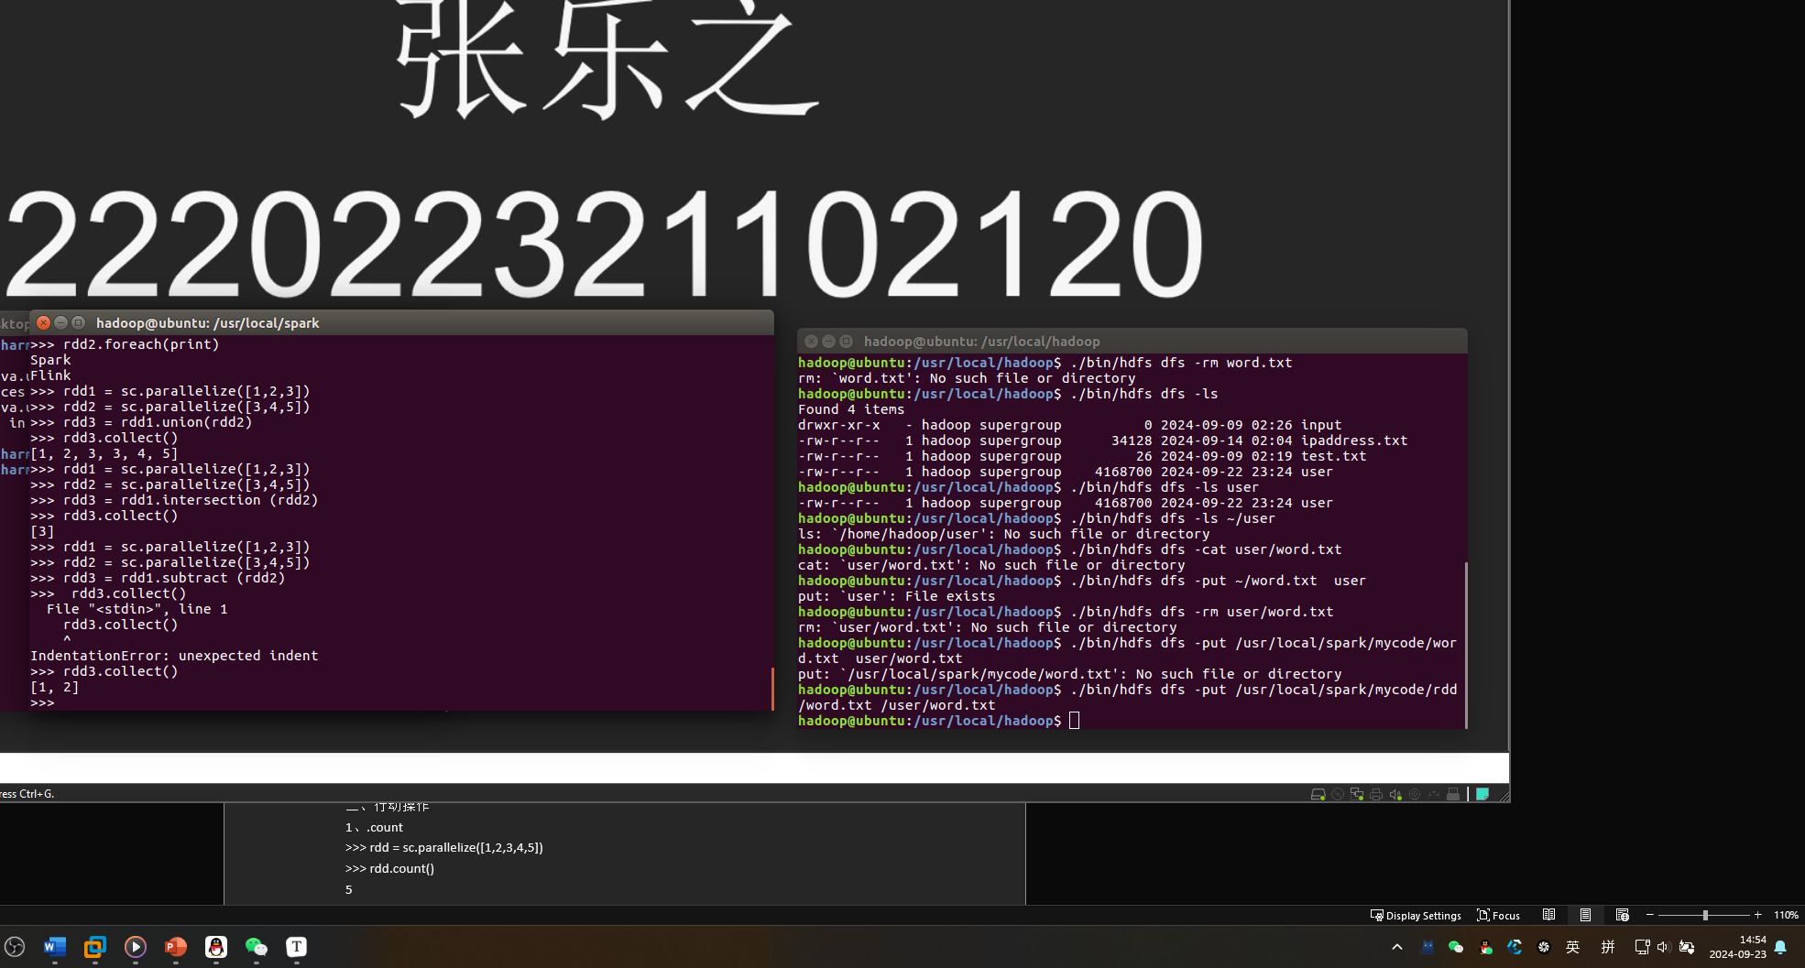

11、zip

>>> rdd1 = sc.parallelize([1,2,3])

>>> rdd2 = sc.parallelize(["Hadoop","Spark","Flink"])

>>> rdd3 = rdd1.zip (rdd2)

>>> rdd3.collect()

[(1, 'Hadoop'), (2, 'Spark'), (3, 'Flink')]

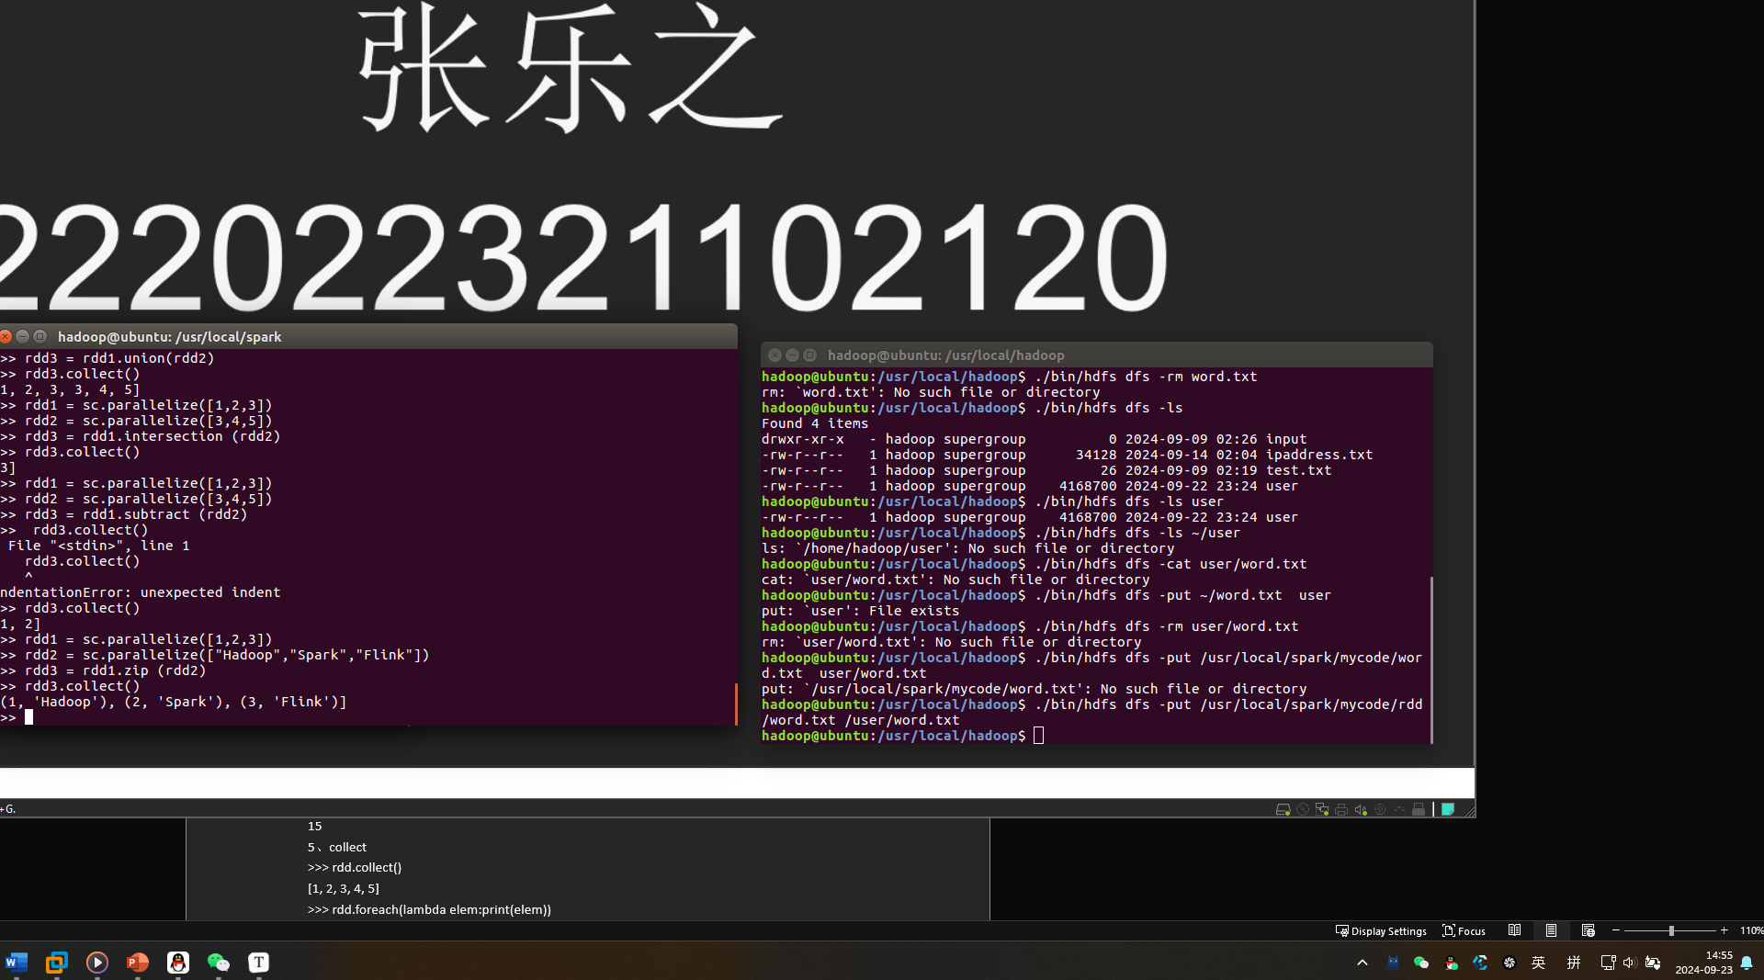

二、行动操作

1、.count

>>> rdd = sc.parallelize([1,2,3,4,5])

>>> rdd.count()

5

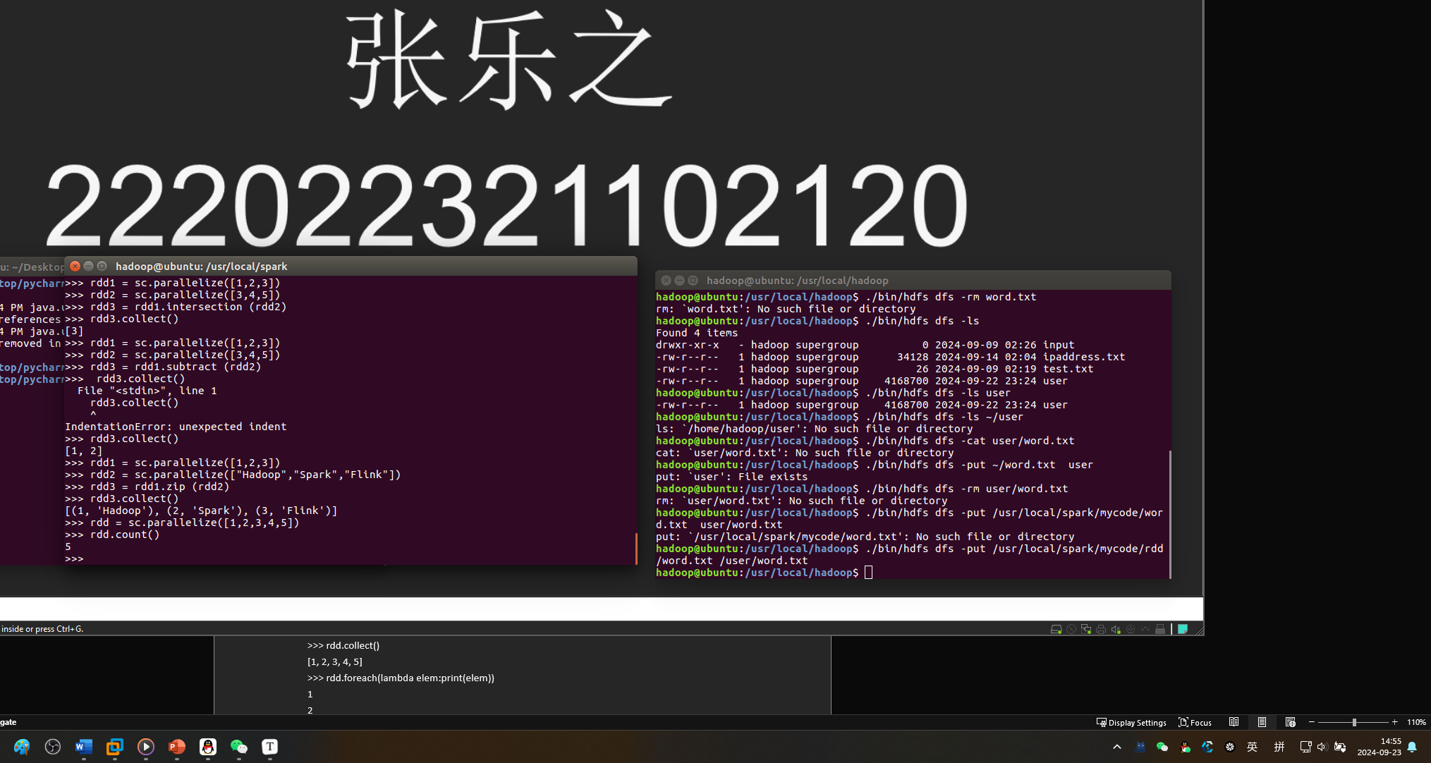

1. first

>>> rdd.first()

1

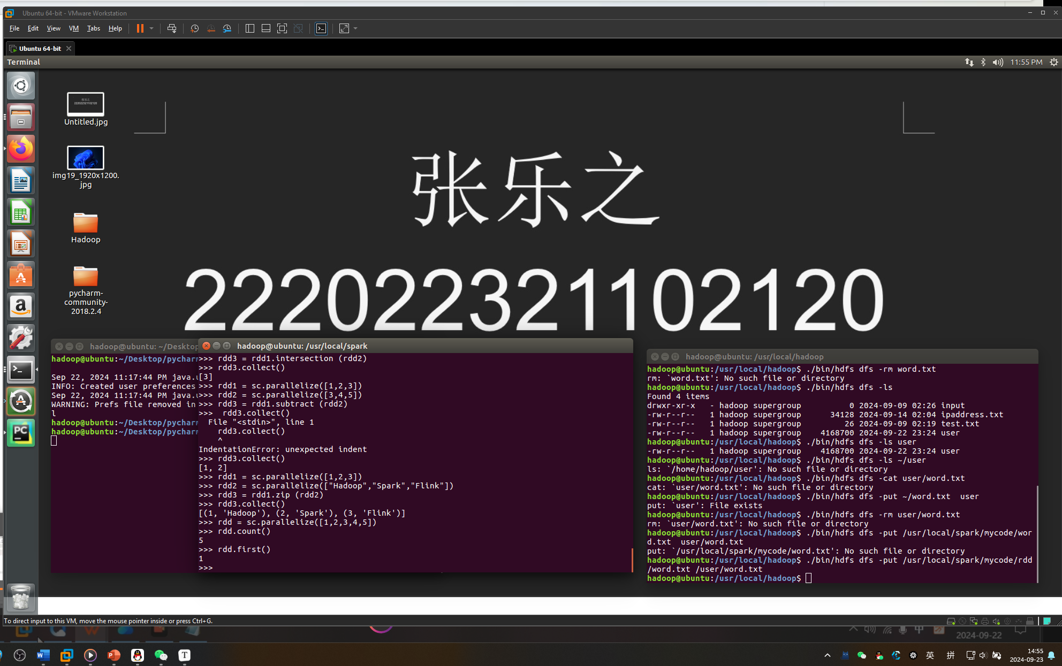

3、take

>>> rdd.take(3)

[1, 2, 3]

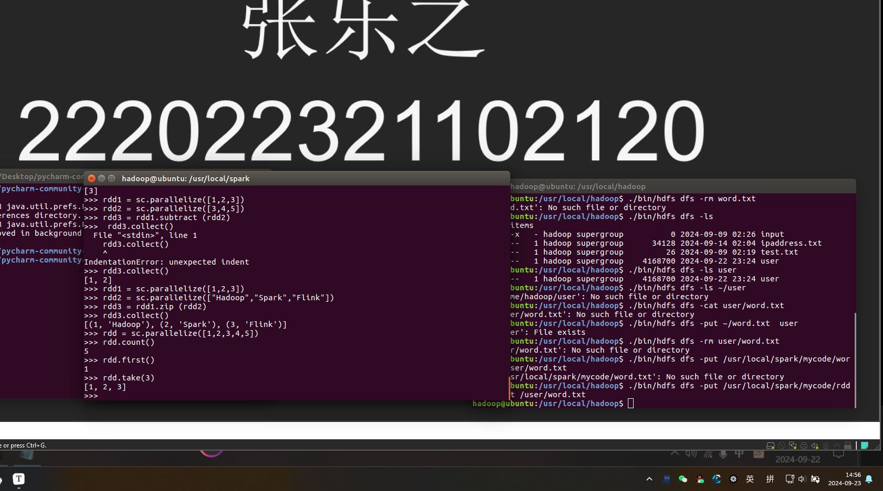

4、reduce

>>> rdd.reduce(lambda a,b:a+b)

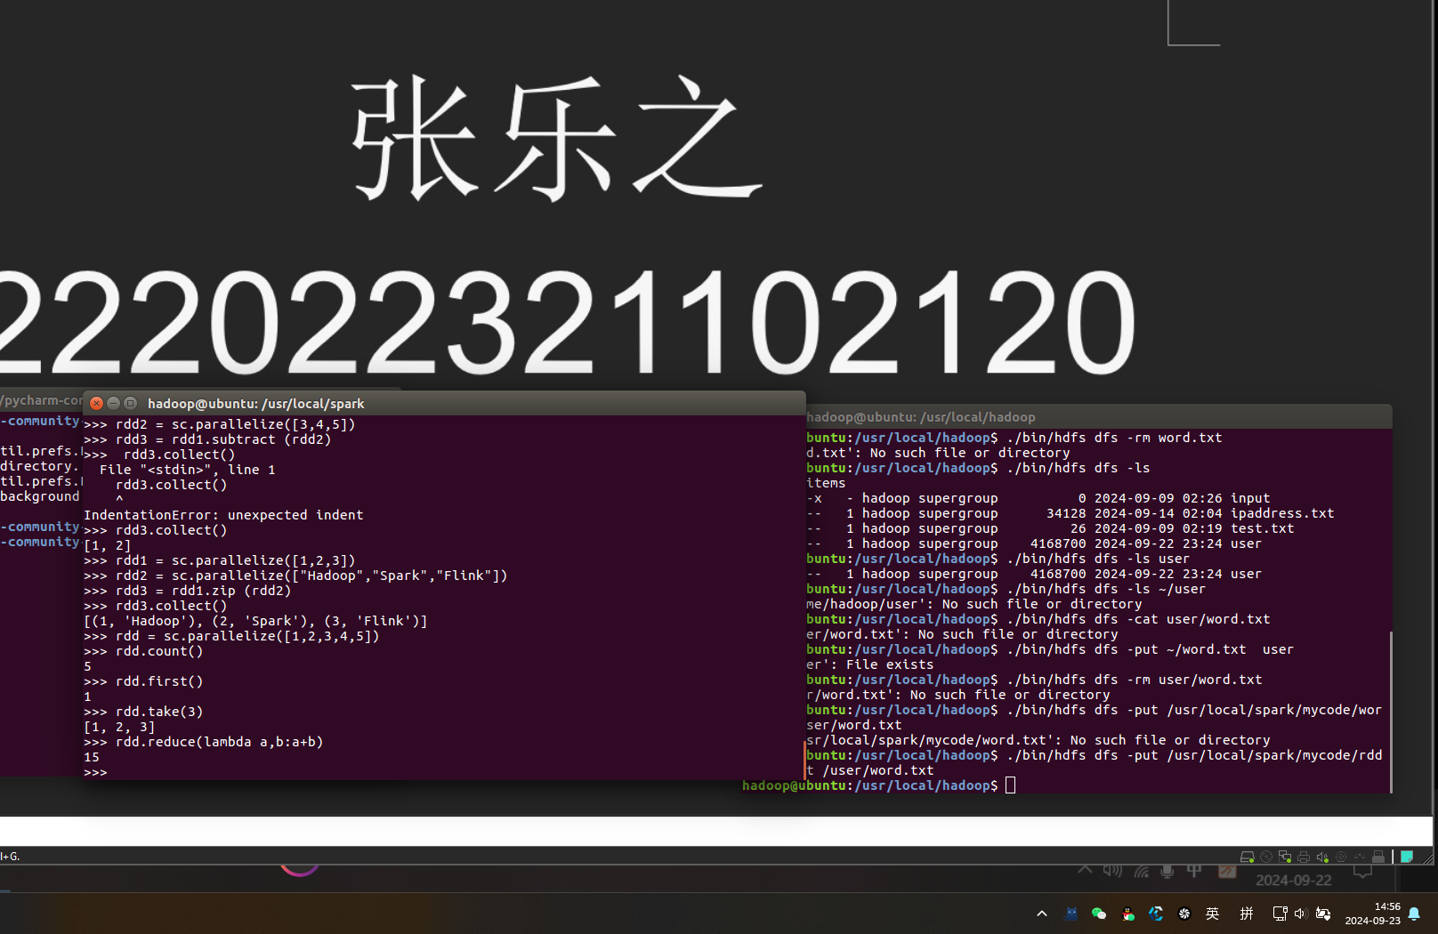

15

5、collect

>>> rdd.collect()

[1, 2, 3, 4, 5]

>>> rdd.foreach(lambda elem:print(elem))

1

2

3

4

5

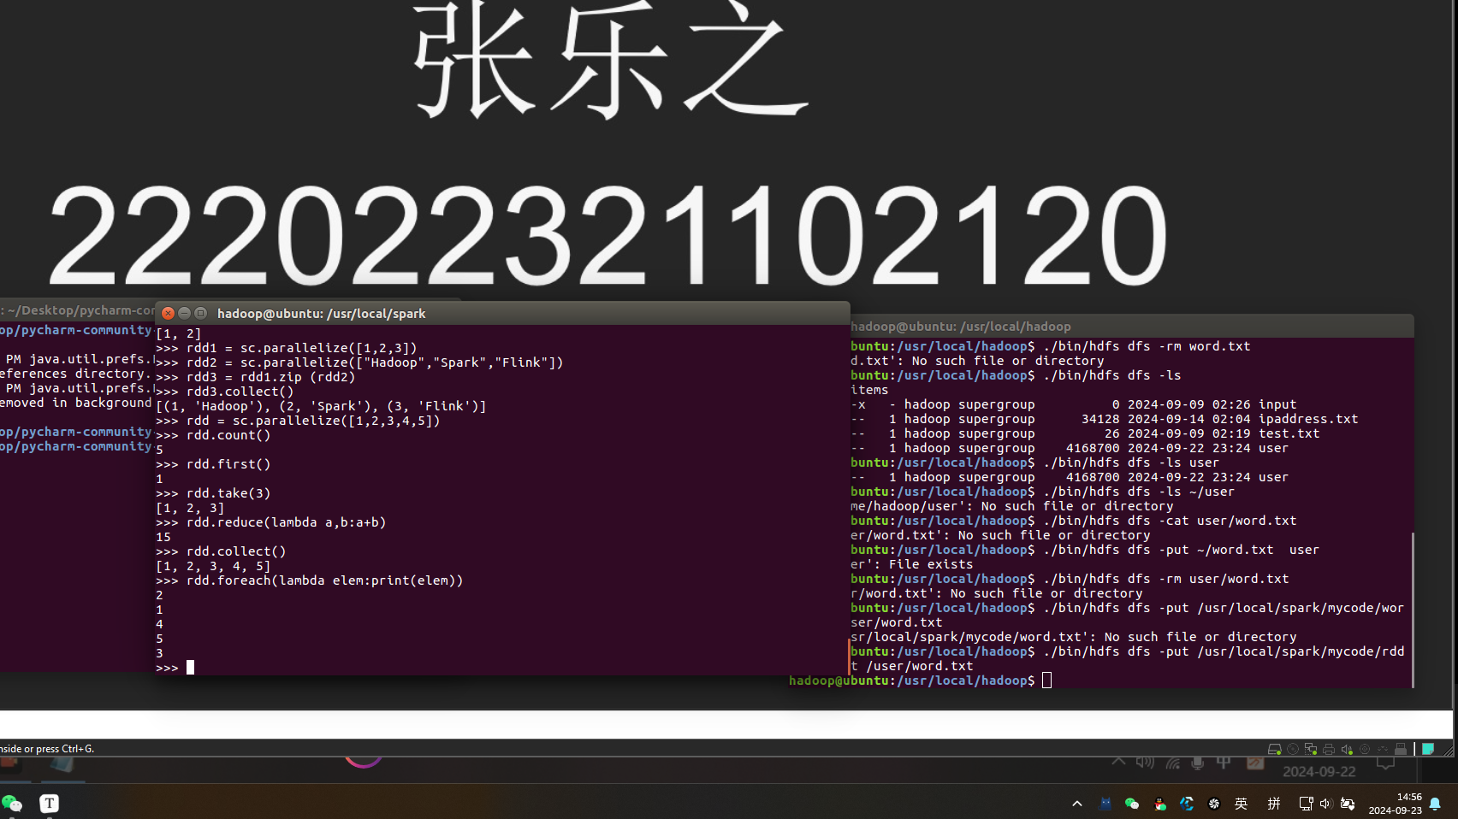

6、countByKey()

>>> rdd = sc.parallelize([("hadoop",1),("spark",1),("spark",1)])

>>> result = rdd.countByKey()

>>> print(result)

defaultdict(<class 'int'>, {'hadoop': 1, 'spark': 2})

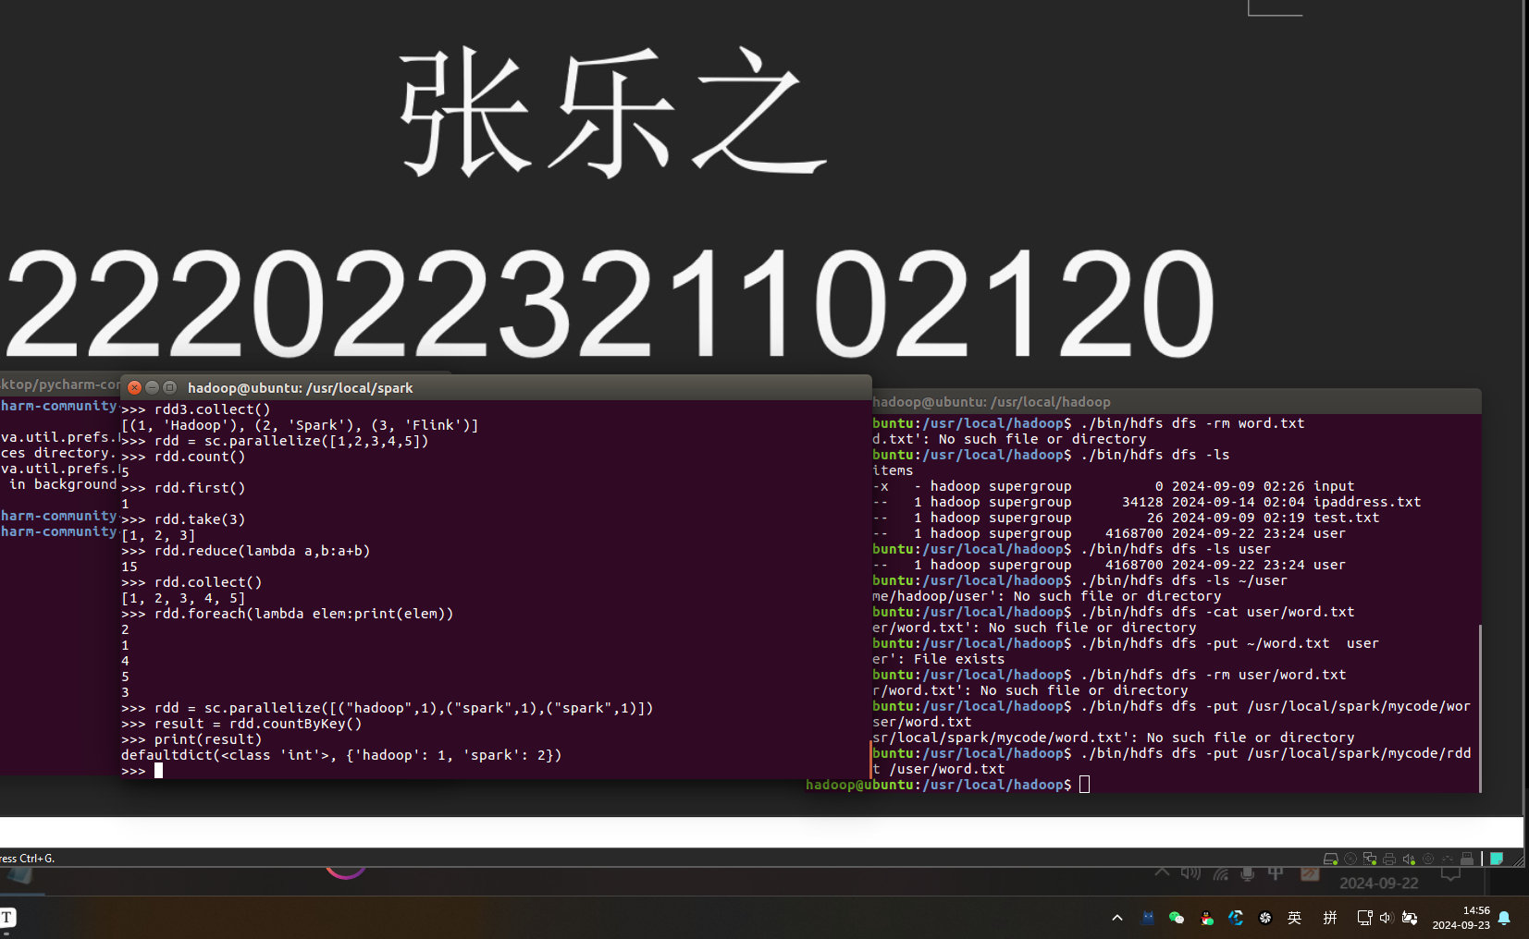

7、aggregate

>>> rdd1 = sc.parallelize([1, 2, 3, 4], 2)

>>> result = rdd1.aggregate(0,lambda a,b:a+b,lambda a,b:a+b)

>>> print(result)

10

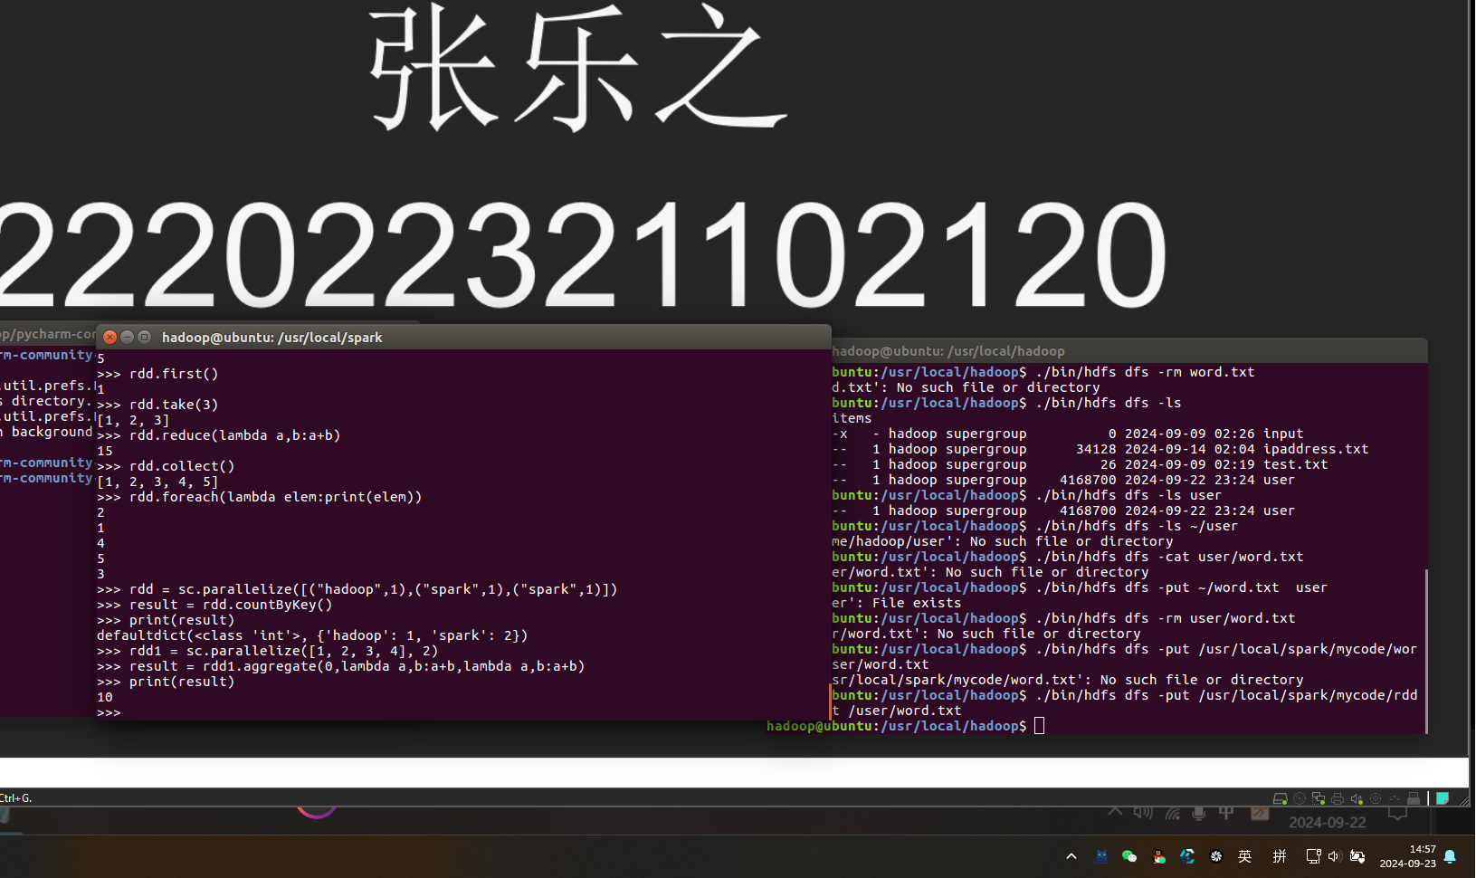

>>> lines = sc.textFile("file:///usr/local/spark/mycode/rdd/word.txt")

>>> lineLengths = lines.map(lambda s:len(s))

>>> totalLength = lineLengths.reduce(lambda a,b:a+b)

>>> print(totalLength)

42

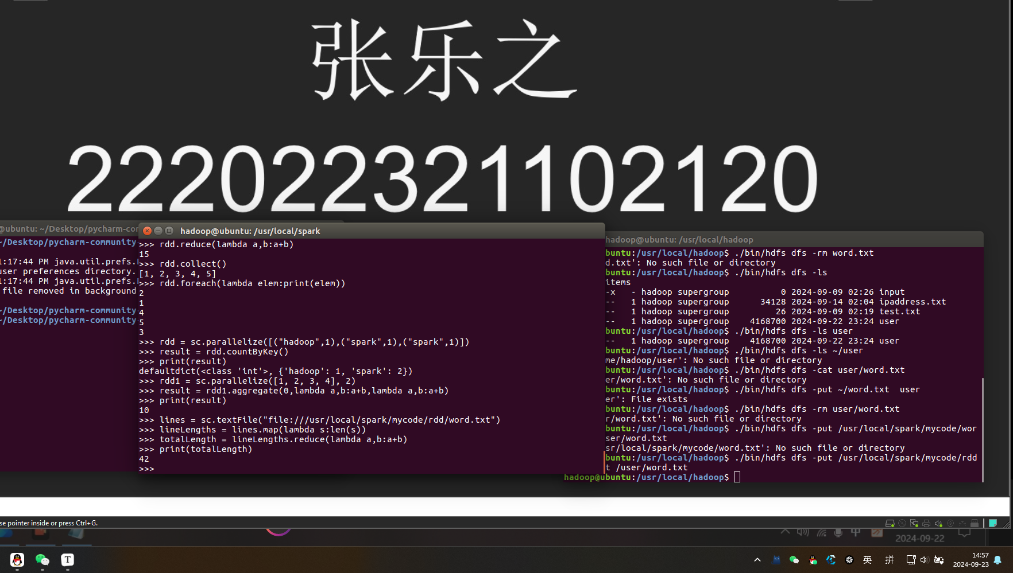

键值操作

1. groupByKey()

>>> list = [("spark",1),("spark",2),("hadoop",3),("hadoop",5)]

>>> pairRDD = sc.parallelize(list)

>>> pairRDD.groupByKey()

PythonRDD[27] at RDD at PythonRDD.scala:48

>>> pairRDD.groupByKey().foreach(print)

('hadoop', <pyspark.resultiterable.ResultIterable object at 0x7f2c1093ecf8>)

('spark', <pyspark.resultiterable.ResultIterable object at 0x7f2c1093ecf8>)

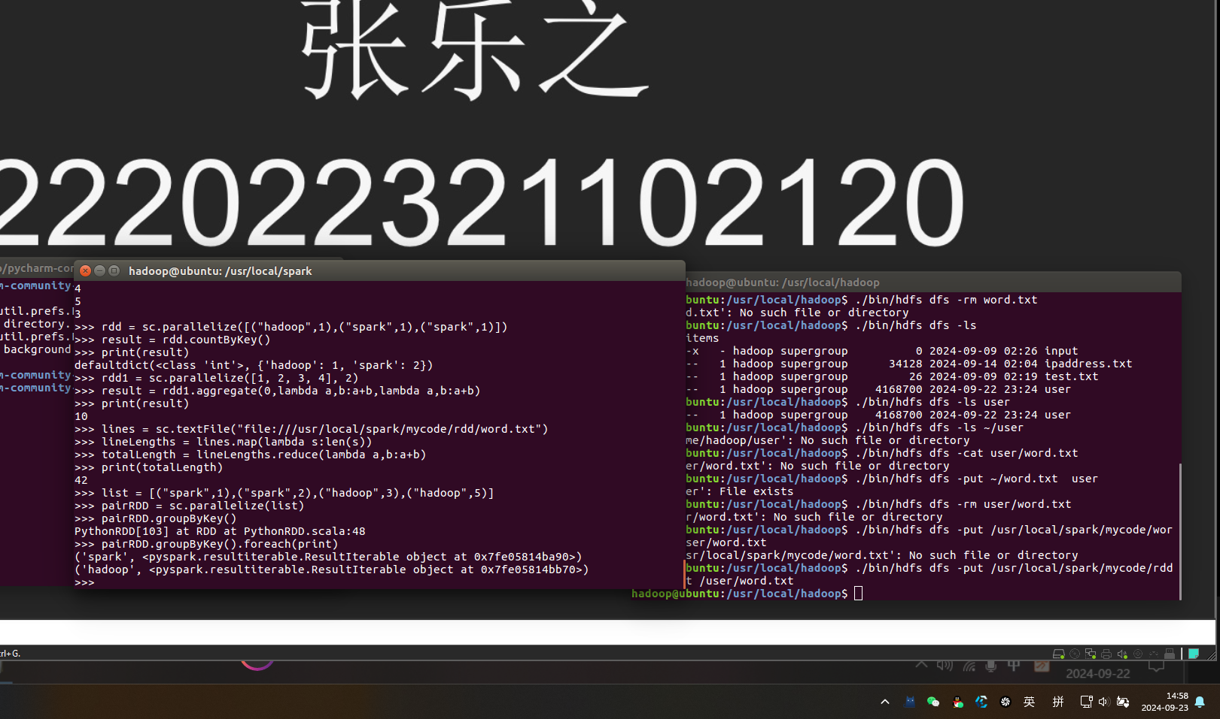

1. reduceByKey(func)

>>> words = ["one", "two", "two", "three", "three", "three"]

>>> wordPairsRDD = sc.parallelize(words).map(lambda word:(word, 1))

>>> wordCountsWithReduce = wordPairsRDD.reduceByKey(lambda a,b:a+b)

>>> wordCountsWithReduce.foreach(print)

('one', 1)

('two', 2)

('three', 3)

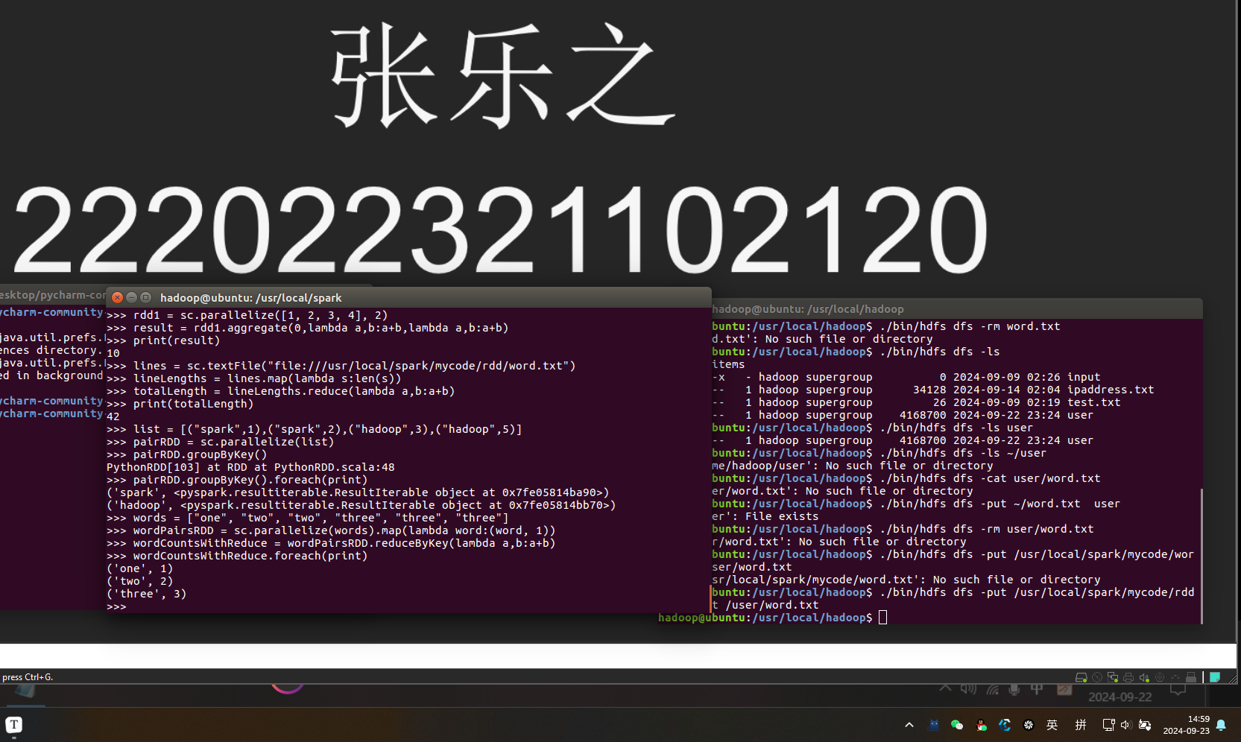

3、sortByKey

>>> list = [("Hadoop",1),("Spark",1),("Hive",1),("Spark",1)]

>>> pairRDD = sc.parallelize(list)

>>> pairRDD.foreach(print)

('Hadoop', 1)

('Spark', 1)

('Hive', 1)

('Spark', 1)

>>> pairRDD.sortByKey().foreach(print)

('Hadoop', 1)

('Hive', 1)

('Spark', 1)

('Spark', 1)

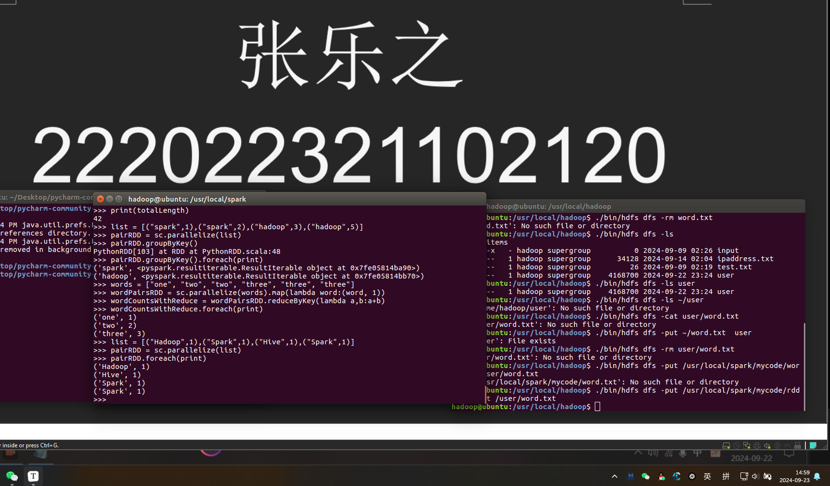

4、mapValues

>>> list = [("Hadoop",1),("Spark",1),("Hive",1),("Spark",1)]

>>> pairRDD = sc.parallelize(list)

>>> pairRDD1 = pairRDD.mapValues(lambda x:x+1)

>>> pairRDD1.foreach(print)

('Hadoop', 2)

('Spark', 2)

('Hive', 2)

('Spark', 2)

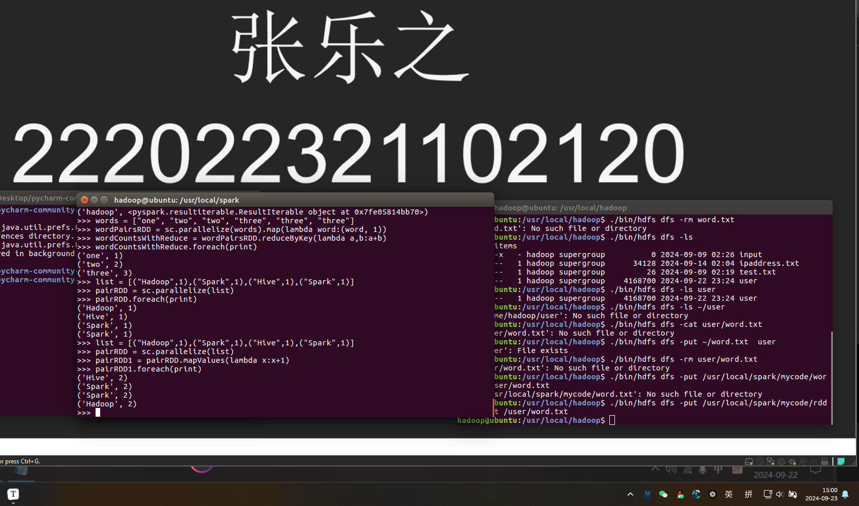

5、join，表示内连接，输入（k,V1), (K,V2), 输出（k,(V1,V2))

>>> pairRDD1 = sc. parallelize([("spark",1),("spark",2),("hadoop",3),("hadoop",5)])

>>> pairRDD2 = sc.parallelize([("spark","fast")])

>>> pairRDD3 = pairRDD1.join(pairRDD2)

>>> pairRDD3.foreach(print)

('spark', (1, 'fast'))

('spark', (2, 'fast'))

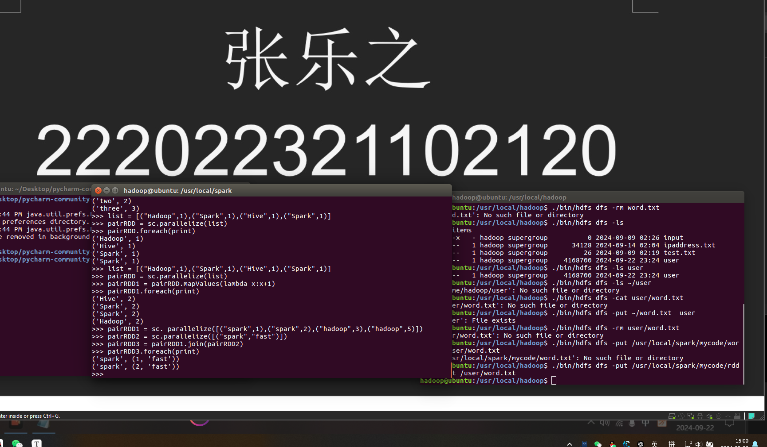

6、Combine

from pyspark import SparkConf, SparkContext

if __name__ == '__main__':

conf = SparkConf().setMaster("local[*]").setAppName("My App")

sc = SparkContext(conf = conf)

data = sc.parallelize([("company-1", 88), ("company-1", 96), ("company-1", 85), \

("company-2", 94), ("company-2", 86), ("company-2", 74), \

("company-3", 86), ("company-3", 88), ("company-3", 92)], 3)

res = data.combineByKey( \

lambda income: (income, 1), \

lambda acc, income: (acc[0] + income, acc[1] + 1), \

lambda acc1, acc2: (acc1[0] + acc2[0], acc1[1] + acc2[1])). \

map(lambda x: (x[0], x[1][0], x[1][0] / float(x[1][1])))

res.repartition(1) \

.saveAsTextFile("file:///usr/local/spark/mycode/rdd/combineresult")

sc.stop()

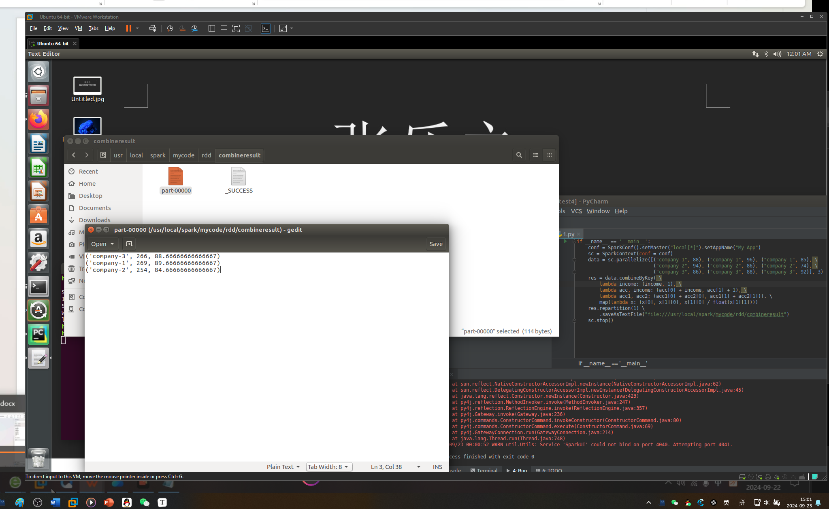

持久化：

>>> list = ["Hadoop","Spark","Hive"]

>>> rdd = sc.parallelize(list)

>>> print(rdd.count()) #行动操作，触发一次真正从头到尾的计算

3

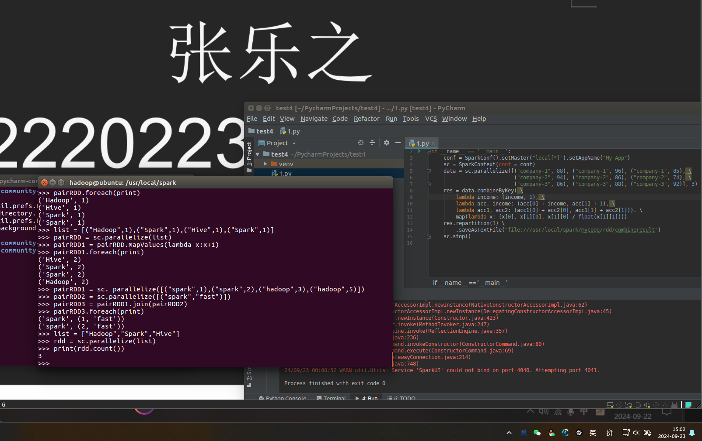

>>> print(','.join(rdd.collect())) #行动操作，触发一次真正从头到尾的计算

Hadoop,Spark,Hive

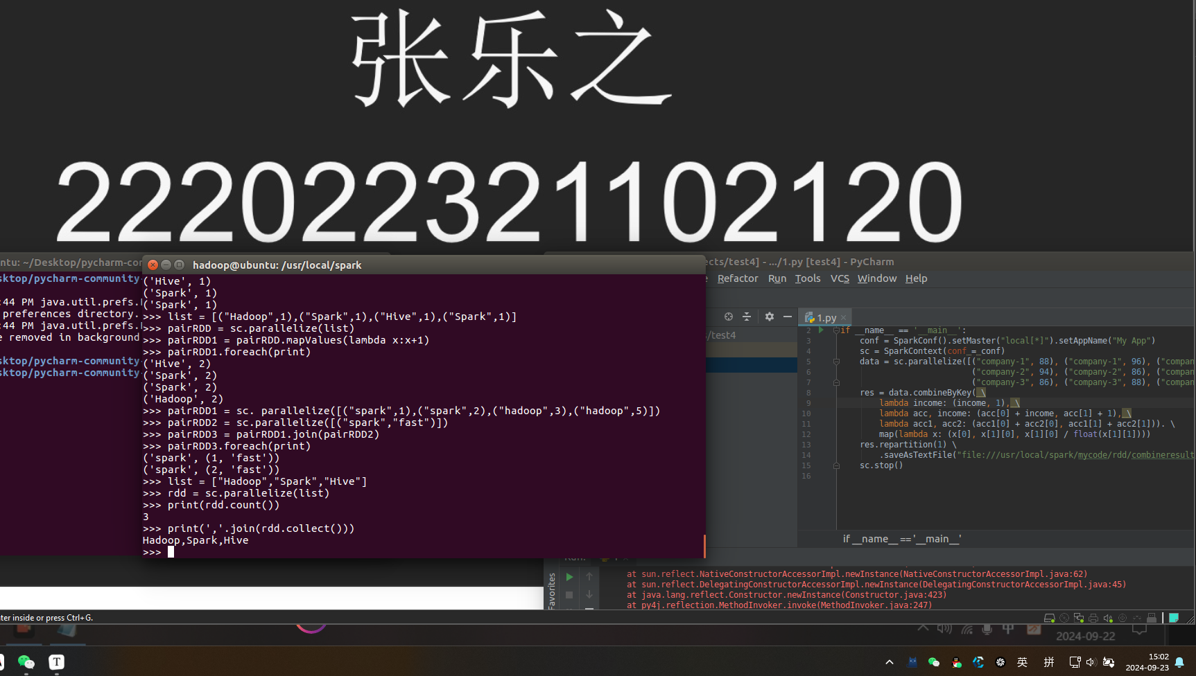

>>> list = ["Hadoop","Spark","Hive"]

>>> rdd = sc.parallelize(list)

>>> rdd.cache() #会调用persist(MEMORY_ONLY)，但是，语句执行到这里，并不会缓存rdd，因为这时rdd还没有被计算生成

>>> print(rdd.count()) #第一次行动操作，触发一次真正从头到尾的计算，这时上面的rdd.cache() #才会被执行，把这个rdd放到缓存中

3

>>> print(','.join(rdd.collect())) #第二次行动操作，不需要触发从头到尾的计算，只需要重复使

#用上面缓存中的rdd

Hadoop,Spark,Hive

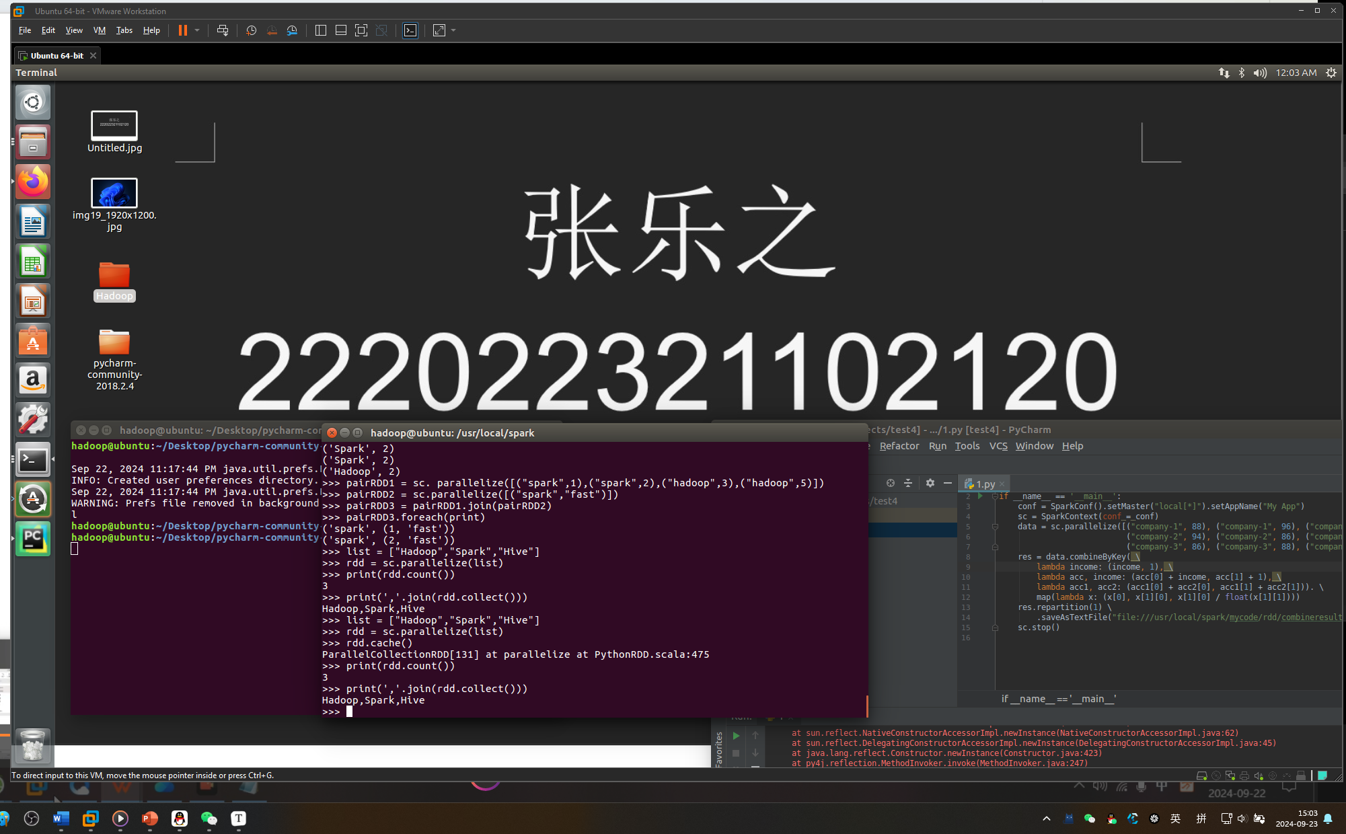

设置分区：

>>> list = [1,2,3,4,5]

>>> rdd = sc.parallelize(list,2) //设置两个分区

>>> data = sc.parallelize([1,2,3,4,5],2)

>>> len(data.glom().collect()) #显示data这个RDD的分区数量

2

>>> rdd = data.repartition(1) #对data这个RDD进行重新分区

>>> len(rdd.glom().collect()) #显示rdd这个RDD的分区数量

1

